ECE 406 Course Notes

Algorithm Design and Analysis

Paolo Torres

**University of Waterloo**

**Winter 2021**

Table of Contents

1 Introduction and Basic Arithmetic 1

1.1 Algorithms, Correctness, Termination, Efficiency 1

1.1.1 Algorithms 1

1.1.2 Correctness 1

1.1.3 Termination 1

1.1.4 Time Efficiency 2

1.1.5 Claim 1 2

1.1.6 More Efficient Algorithm 3

1.1.7 Note on Measuring Time Efficiency 3

1.2 Big-O Notation 3

1.2.1 Definition 1 (O) 3

1.2.2 Definition 2 () 3

1.2.3 Definition 3 () 3

1.2.4 Example 4

1.2.5 Big-O Explanation 4

1.2.6 Big-O Simplifications 5

1.3 Arithmetic 5

1.3.1 Addition 5

1.3.2 Multiplication 5

1.3.3 Division 6

2 Algorithms with Numbers 8

2.1 Modular Arithmetic 8

2.1.1 Example Application: Two’s Complement Arithmetic 8

2.1.2 Modular Addition, Subtraction 8

2.1.3 Modular Multiplication 9

2.1.4 Modular Exponentiation 9

2.1.5 Towards Modular Division: GCD Using Euclid 9

2.1.6 Towards Modular Division: Extended Euclid 10

2.1.7 Modular Division 11

2.2 Primality Testing 11

2.2.1 Fermat’s Little Theorem 12

2.3 Generating an n-Bit Prime 13

2.4 Cryptography 14

2.4.1 Claim 1 14

2.4.2 Example 14

2.4.3 Attacks 15

2.4.4 Proof for Claim 1 15

3 Universal Hashing, Divide and Conquer 17

3.1 Universal Hashing 17

3.1.1 Example 17

3.1.2 Two Possible Candidates for 17

3.1.3 Hash Table Objectives 18

3.1.4 Problem Setup 18

3.1.5 How a Hash Table Works 18

3.1.6 Universal Hashing 19

3.1.7 How to Construct Given 20

3.2 Divide and Conquer 22

3.2.1 Definition 22

3.2.2 Solving Recurrences 24

3.2.3 Sorting Problem 25

3.3 Divide and Conquer Applications 26

3.3.1 Selection Problem 26

3.3.2 Matrix Multiplication 28

4 Decompositions of Graphs, Paths 30

4.1 Graphs 30

4.1.1 Representing a Graph 30

4.1.2 Graph Exploration 31

4.2 DFS, Continued 33

4.2.1 Directed Acyclic Graph (DAG) 34

4.2.2 Strongly Connected Components 34

4.3 Shortest Paths 37

4.3.1 Breadth First Search (BFS) 37

5 Paths in Graphs, Continued 40

5.1 Shortest Paths in Weighted Graphs 40

5.1.1 Dijkstra’s Algorithm 40

5.1.2 Correctness 43

5.1.3 Time Efficiency of Dijkstra 45

5.2 Shortest Paths and Negative Edge Weights 47

5.2.1 Bellman-Ford Algorithm 48

5.2.2 Directed Acyclic Graphs (DAGs) 49

6 Greedy Algorithms 50

6.1 Greedy Algorithms 50

6.1.1 Minimum Spanning Trees 50

6.1.2 Correctness of Kruskal 51

6.1.3 Time Efficiency of Kruskal 52

6.2 Path Compression 56

6.2.1 Analyzing the Benefit from Path Compression 58

6.3 Prim’s Algorithm, and Min-Cut 59

6.3.1 Prim’s Algorithm 59

6.3.2 Min-Cut 61

6.4 Huffman Coding and Horn Formulas 62

6.4.1 Huffman Coding 62

6.4.2 Horn Formulas 65

# Introduction and Basic Arithmetic

## Algorithms, Correctness, Termination, Efficiency

### Algorithms

Given the specification for a function, an algorithm is the procedure to compute it.

Example:

, where

Commonly used sets:

Fibonacci Sequence:

Important aspects:

* Function has been specified as a recurrence, so a recursive algorithm seems natural
* Imperative (procedural) specification of an algorithm has consequences:
  + Intuiting correctness can be a challenge
  + Intuiting time and space efficiency may be easier
* No mundane error checking, can focus on core logic
* Input value is unbounded but finite

### Correctness

Correctness refers to an algorithm’s ability to guarantee expected termination. In the case of , it is a direct encoding of the recurrence.

### Termination

The end of an algorithm. It can be proven that terminates on every input by induction on .

### Time Efficiency

Can be calculated by counting the number of: comparisons – these happen on Lines and , and number of additions – this happens on Line .

Suppose represents the time efficiency of :

How bad is ? Is it exponential in ?

For all , .

### Claim 1

For all

If this claim is true, then , and because , is exponential in .

Proof for the claim: by induction on .

Does a better algorithm exist from the standpoint of time efficiency?

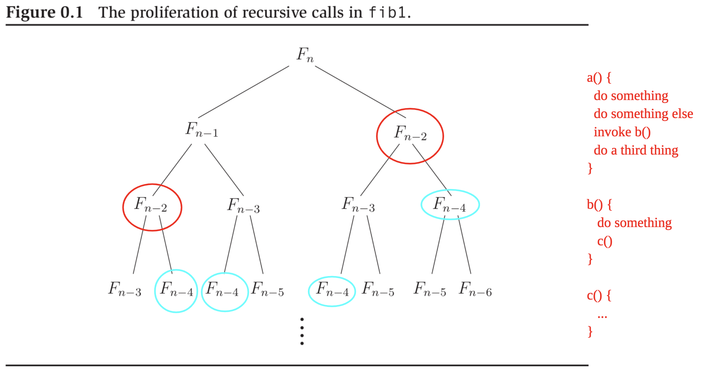

Recall how subroutine (recursive, in this case) invocation works:

* Every node in the tree corresponds to an invocation of the algorithm
* Sequence of invocations corresponds to a pre-order traversal
* Maximum depth of the call stack at any moment:

Main point in this case: Redundancy, , appears more than once.

### More Efficient Algorithm

Let be the of comparisons plus additions on input :

Linear in for , more efficient than .

### Note on Measuring Time Efficiency

Need to pick the right level of abstraction, meaning picking some kind of “hot spot” or “hot operation,” then count. For example, number of additions, comparisons, recursive calls, etc.

## Big-O Notation

### Definition 1 (O)

Let , and be functions. Define if there exists a constant such that .

* Typically consider non-decreasing functions only

### Definition 2 ()

Define if

### Definition 3 ()

Define if and

* analogous to
* analogous to
* analogous to

### Example

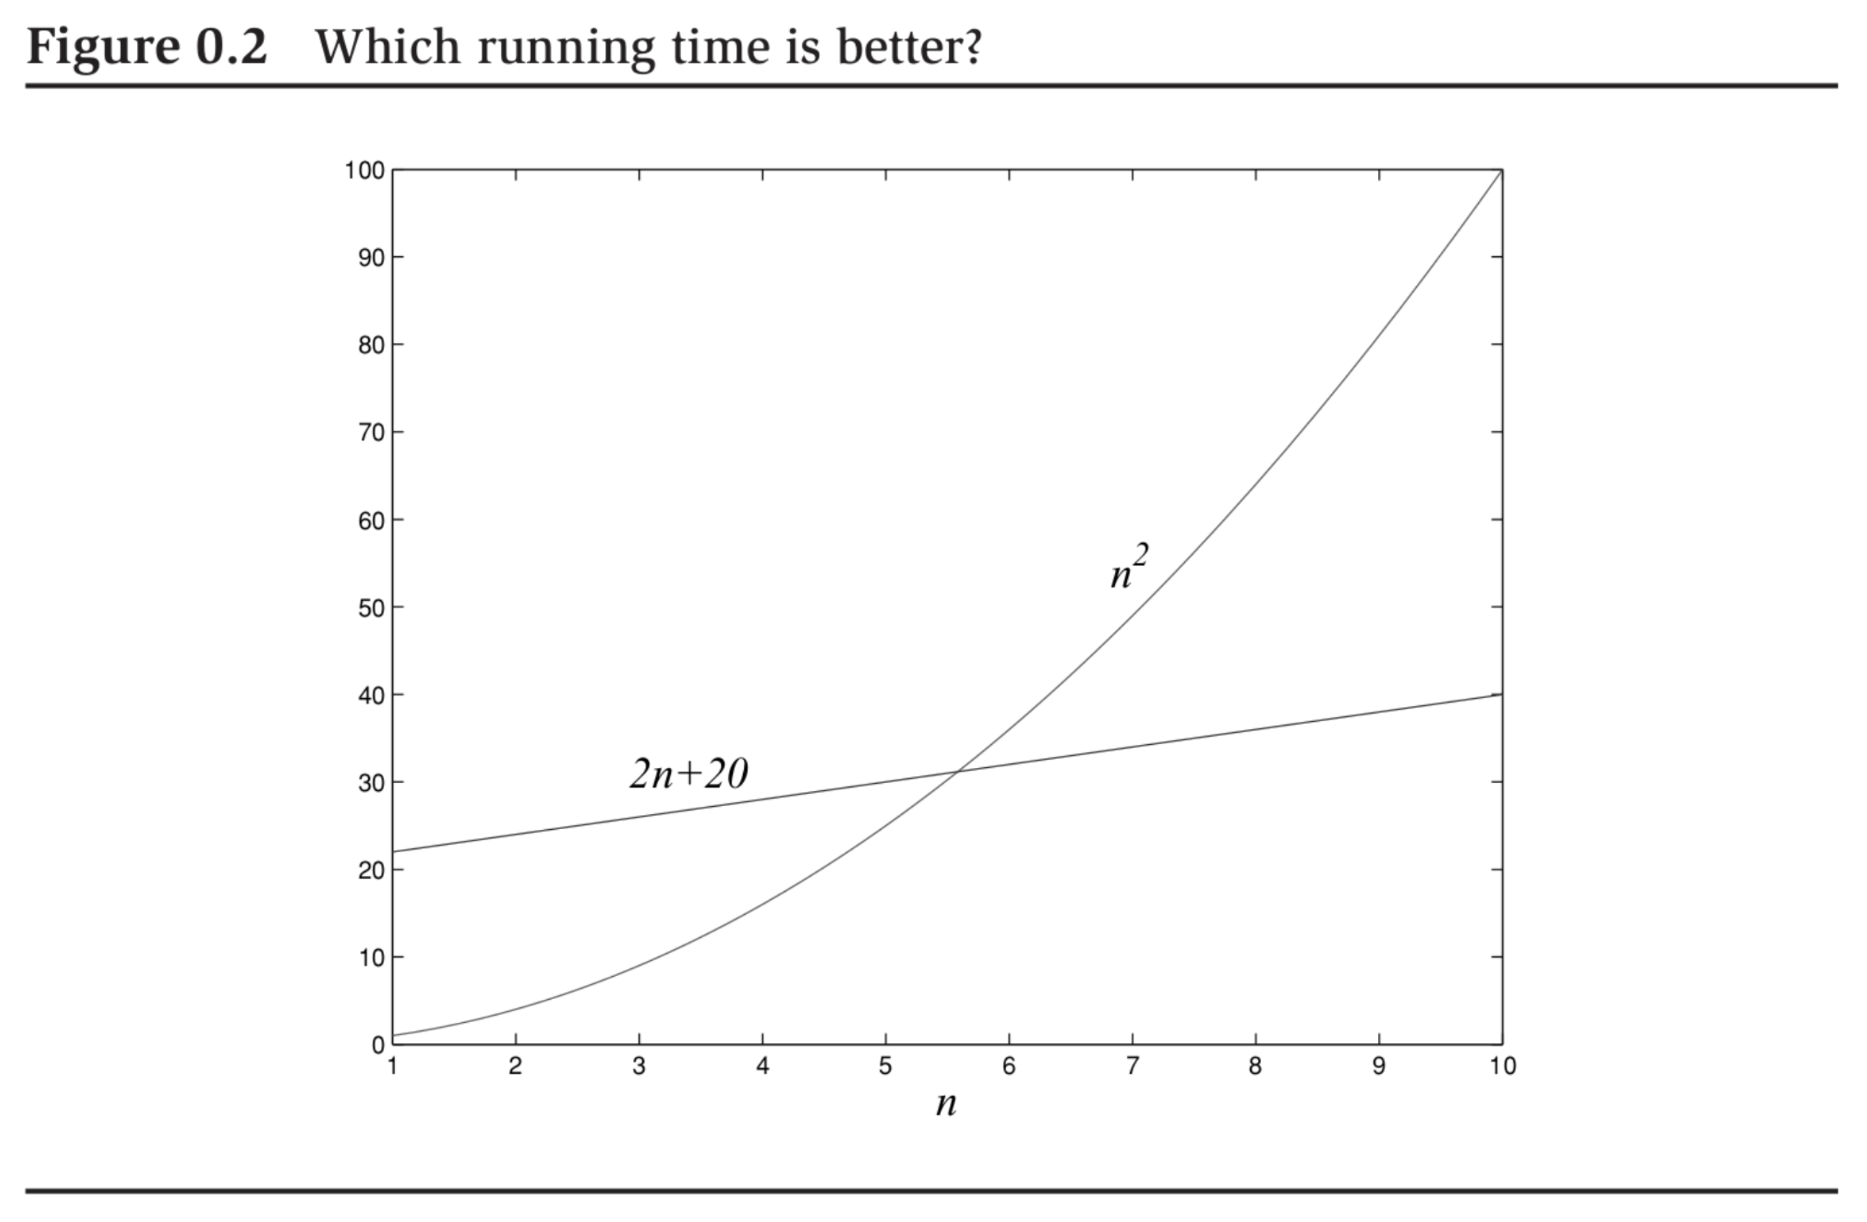

Precise answer to this question: depends on .

But in big-O notation:

* . Proof: Adopt as the constant for any

### Big-O Explanation

Suppose algorithm A runs in time, B in , and C in . Now suppose the speed of the computer doubles, which algorithm gives the best payoff?

For a given time period , what is the largest input each algorithm can handle? Set and , solve for :

|  |  |  |
| --- | --- | --- |
| **Algorithm** | **Old Computer** | **New Computer** |
| A |  |  |
| B |  |  |
| C |  |  |

So, payoff with algorithm A is approximately , B is , and C is .

### Big-O Simplifications

* Multiplicative and additive constants can be omitted
* dominates for
* Any exponential dominates any polynomial, any polynomial dominates any logarithm
* Big-O simplifications should be used prudently, not applicable in all settings

## Arithmetic

### Addition

Hypothesize access to a function :

|  |  |  |  |  |
| --- | --- | --- | --- | --- |
| **Carry** | **One Digit** | **Other Digit** | **Result Carry** | **Result Sum** |
| 0 | 0 | 0 | 0 | 0 |
| 1 | 0 | 0 | 0 | 1 |
| 0 | 0 | 1 | 0 | 1 |
| … | | | | |
| 1 | 8 | 9 | 1 | 8 |
| 0 | 9 | 9 | 1 | 8 |
| 1 | 9 | 9 | 1 | 9 |

To add and :

digits needed to encode

bits needed to encode

So, time efficiency of an algorithm to add as measured by number of lookups to T:

* in the best case
* in the worst case
* So, either way, , or linear time, where is the size of the input

### Multiplication

For , encoded in binary:

Straightforward encoding as recursive algorithm .

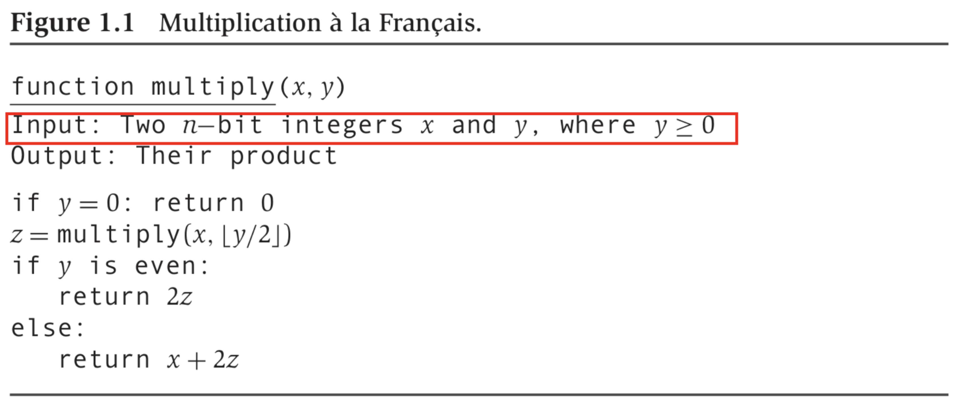

Worst case running time:

* + One comparison to , one division by (right bit shift), one assignment to , one check for evenness (check LSB), one multiplication by (left bit shift), one addition of -bit numbers
* So, in the worst case

### Division

**Definition 1:** Given , the pair where , of divided by are those that satisfy:

**Claim 1:** For every , , as defined above exists, and is unique.

To specify a recurrence for , denote as , the result of divided by . Now:

**Claim 2:** The above recurrence is correct.

*Proof:* Cases are exhaustive. Proof by case-analysis and induction on bits to encode .

By induction assumption: .

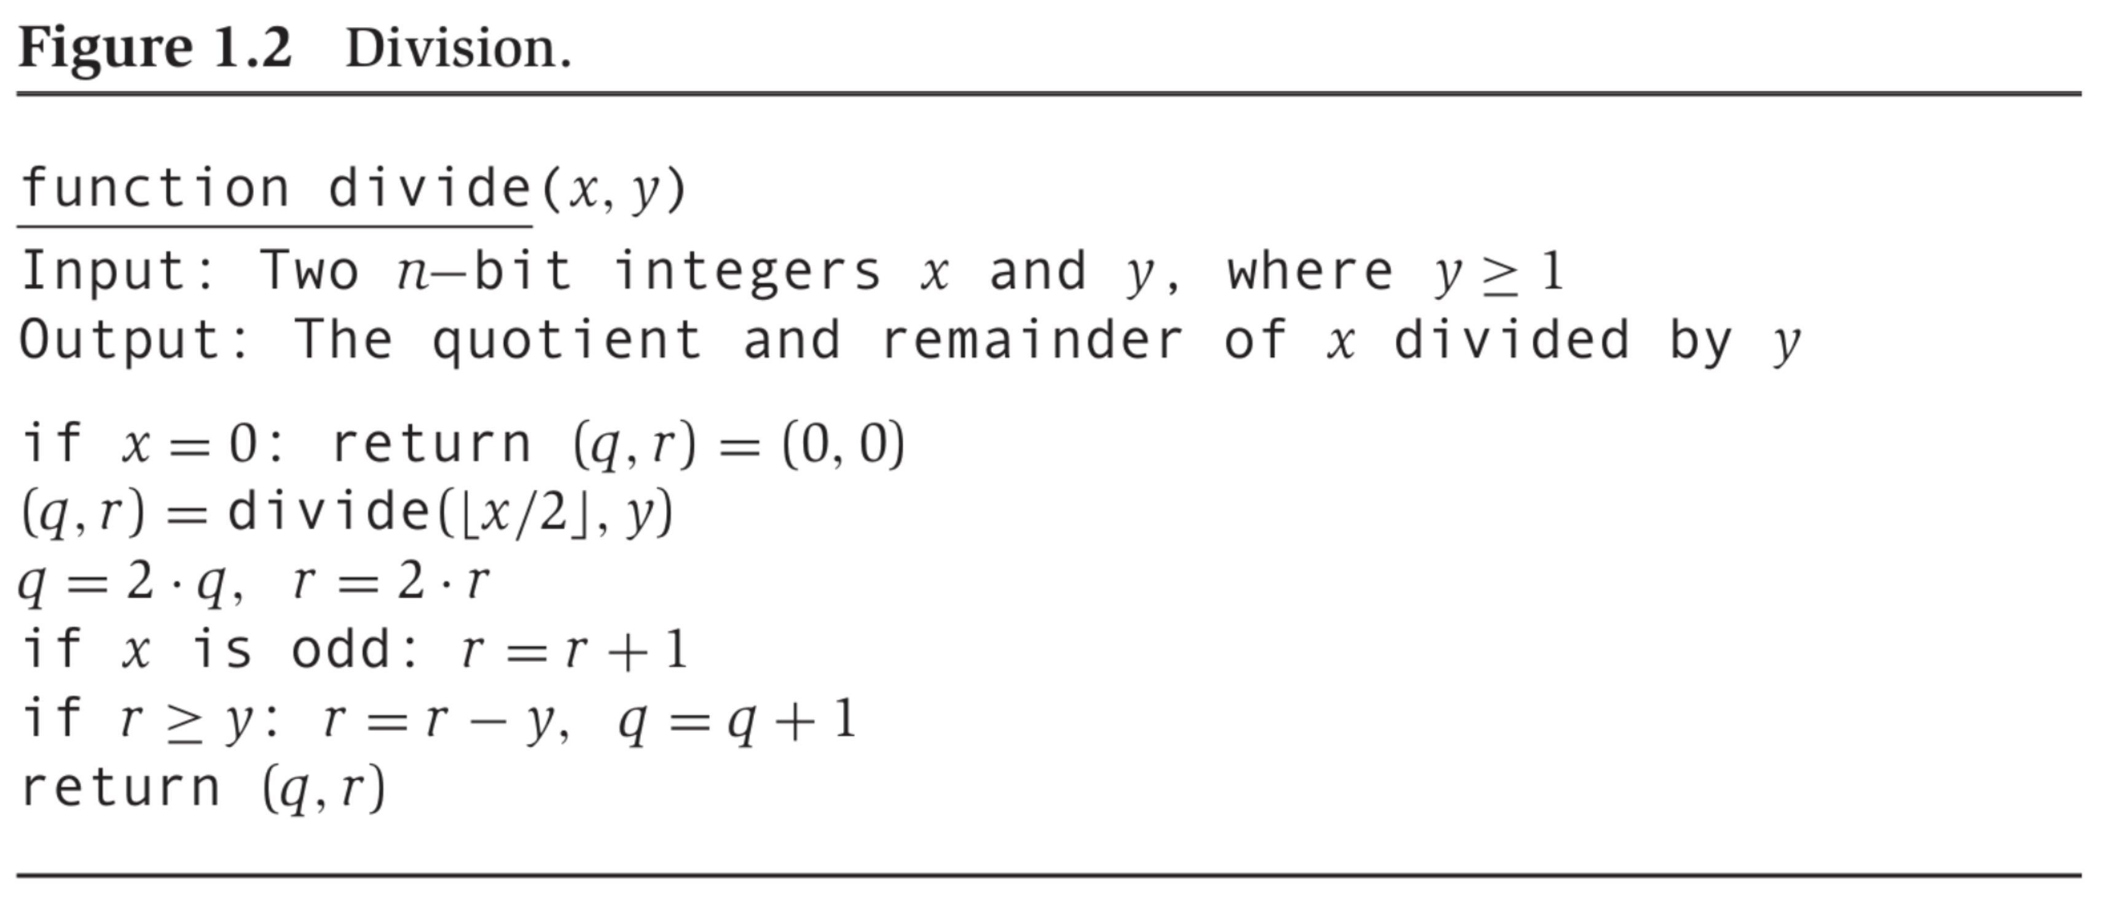

Running time: .

# Algorithms with Numbers

## Modular Arithmetic

* **Definition 1:**
* **Definition 2:** 
  + Example:

### Example Application: Two’s Complement Arithmetic

Suppose we want to represent, using bits, positive and negative integers, and . Could reserve bit for sign. This would allow us to represent integers in the interval , with a “positive zero” and a “negative zero.”

In two’s complement arithmetic, we have exactly one bit-string for , and represent integers in the interval . How? Represent any as the non-negative integer modulo . So:

* Ex:
* Ex:

All arithmetic performed modulo :

* Ex:

**Claim 1:**

**Claim 2:**

(mod N) (mod N) (mod N)

Example:

### Modular Addition, Subtraction

* Any intermediate result is between and
* So, time efficiency is , where

### Modular Multiplication

Let and be our algorithms for non-modular multiplication and division:

* Any intermediate result (specifically, result of ) is between and
* So, time efficiency is , where

### Modular Exponentiation

* Recall: We used “repeated doubling” for non-modular multiplication and “repeated halving” for non-modular division
* Similarly, here, use “repeated squaring”:

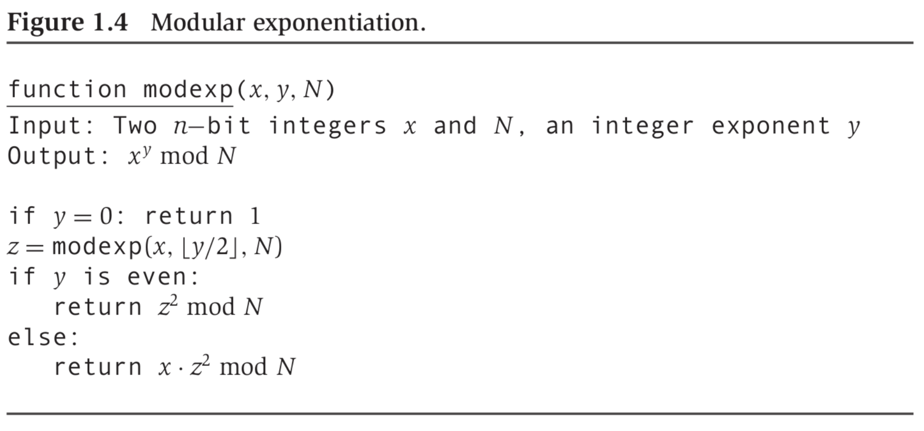

### Towards Modular Division: GCD Using Euclid

* In a non-modular world, . Only case for which doesn’t exist:
* In a modular world, may not exist even if

Crucial building block: GCD. Example: What is ?

But factoring into prime factors conjectured to be computationally hard in the worse case

**Claim 3:**

*Proof:* Suffices to prove: . Now prove and .

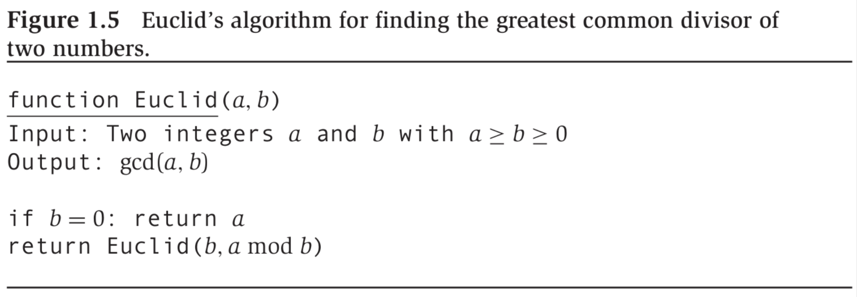

How fast does converge?

**Claim 4:**

So: Guaranteed to lose at least bit for every recursive call time efficiency is

### Towards Modular Division: Extended Euclid

**Claim 5:**

**Claim 6:**

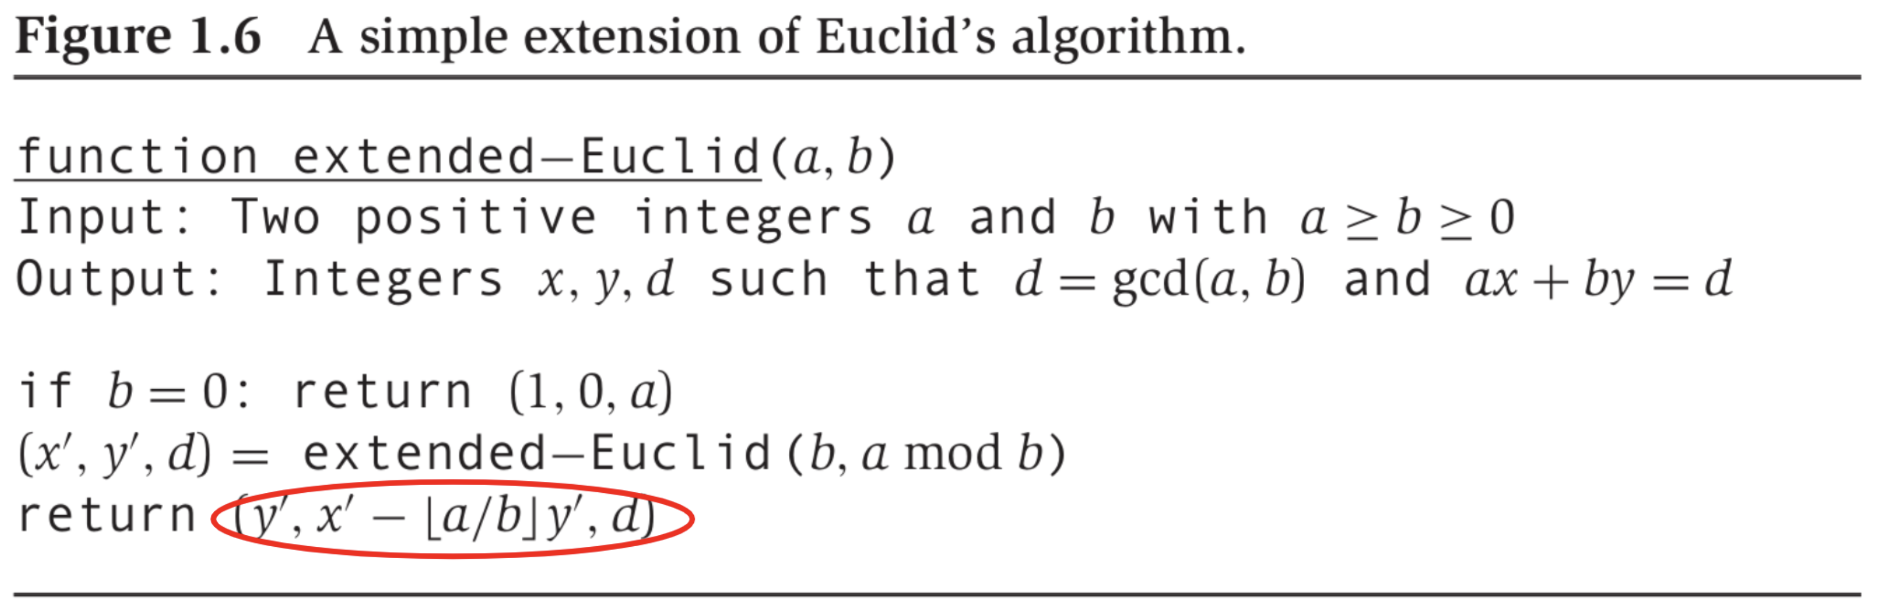

Example run on input :

|  |  |
| --- | --- |
| **Arguments** | **Return Value** |
|  |  |
|  |  |
|  |  |
|  |  |
|  |  |
|  |  |
|  |  |
|  |  |

A good example to segue to our final step in modular division.

We figured out: , which implies:

* . So: is multiplicative inverse of
* So, for example:

### Modular Division

**Definition 3:**

**Claim 7:**

**Claim 8:**

**Definition 4:**

**Claim 9:**

So, to compute :

1. Determine whether
2. If yes to (i) determine , and
3. If yes to (i) compute

(i) and (ii) are done simultaneously by

Running Time:

## Primality Testing

Given , is prime?

For a decision problem, i.e., co-domain of function to be computed as , a randomized algorithm:

* Has access to an unbiased coin
* Is deemed to be correct if:

Suppose:

* We run such an algorithm times, pairwise independently
* We return if and only if every run returns
* Then,

### Fermat’s Little Theorem

**Claim 1:**

To prove Fermat’s little theorem, leverage the following:

**Claim 2:**

*Proof for Claim 2:* We know that are relatively prime, so exists.

*Proof for Claim 1:* From Claim 2:

Also, exists.

So,

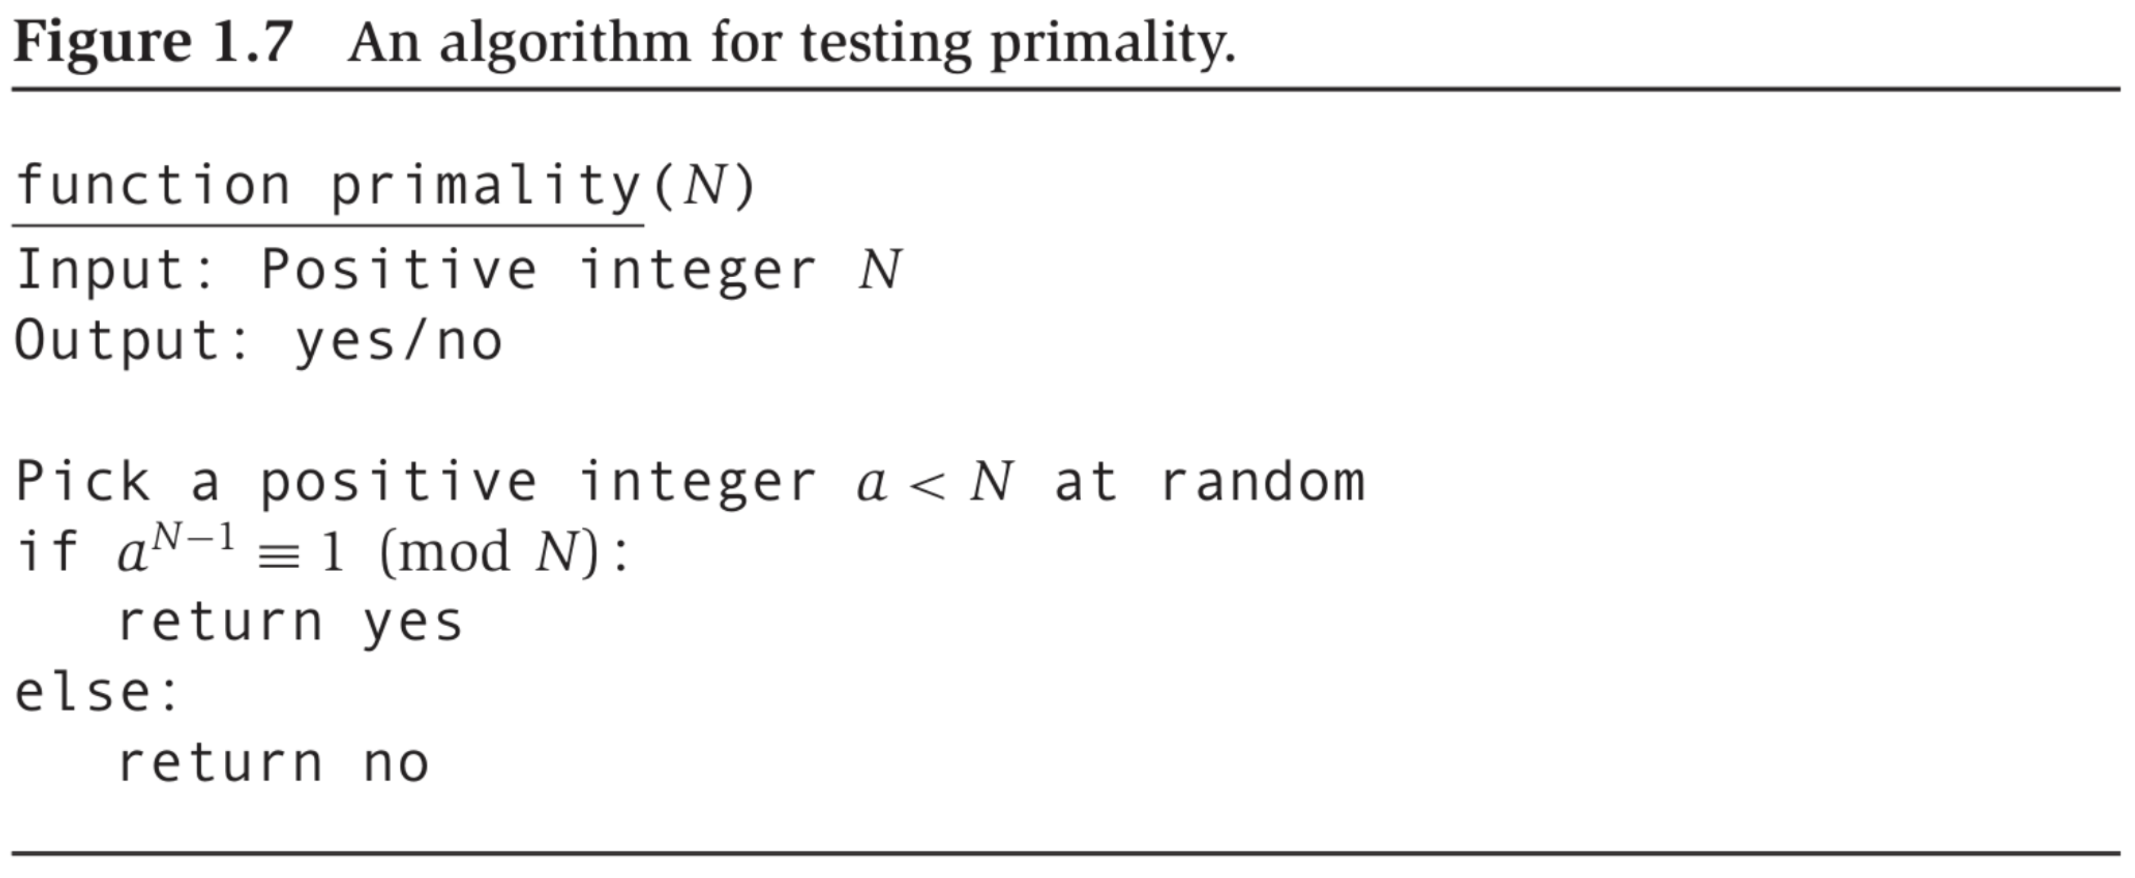

Issues with the algorithm:

1. Fermat’s little theorem is not an “if and only if”: Carmichael numbers.
2. Suppose is not prime/Carmichael. For chosen, say, uniformly from , what is ?

* We know such an exists, but how likely is it that we will pick it?

We do not deal with (1) – cop out: Carmichael numbers are rare.

**Claim 3:** If for relatively prime, then it must hold for at least half the choices .

*Proof:* If there exists no with , then we are done.

If such a exists, then .

Also, if exist with , , then:

So, at least as many as there are .

So:

For runs of on uniform, independent choices of :

## Generating an n-Bit Prime

**Claim 4:** .

So, algorithm for generating a prime:

1. Randomly generate -bit number, .
2. Check whether is prime.
3. If not, go to Step (1).

Guaranteed return in Step (2) if is indeed prime.

Each trial in the above algorithm is a Bernoulli trial:

* Only one of two outcomes: success or failure

In a Bernoulli trial if , then

* Example:
* Example:

So, we expect the above algorithm to halt in iterations.

## Cryptography

**RSA:** Exploits presumed computational hardness of factoring vs. computational ease of GCD, primality testing and modular exponentiation.

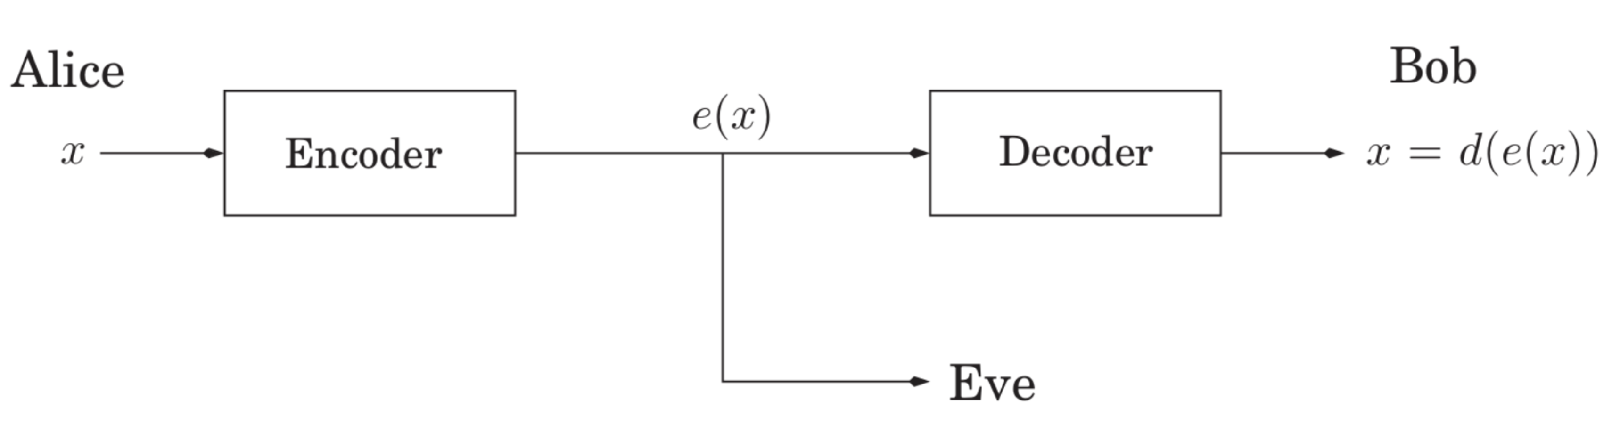

Symmetric Key Cryptography:

* + Example:
* They keep these secrets from everyone else
* Bootstrapping Problem: How do Alice and Bob share , ?

Public Key Cryptography:

* Bob publishes to the whole world
* Bob keeps to himself
* RSA is an example of a public key cryptography scheme

### Claim 1

Let be primes and . For any relatively prime to :

1. The function where is a bijection
2. Let . Then,

Bob publishes the pair . Alice encodes message as from the claim.

Bob keeps the in the claim secret to themselves.

### Example

. Then, . The only messages that can be sent: .

We could pick :

Then, : .

To send the message , Alice would send .

Bob would decode the message as .

### Attacks

Attacker knows: (i) , (ii) .

* Attack 1: Attacker determines given (i) and (ii).
* Attack 2: Even more devastating – attacker factors .
  + They can then compute .

### Proof for Claim 1

Property #2 implies Property #1.

To prove Property #2:

Because for some .

We seek to show: is divisible by , and is therefore .

Now, by Fermat’s little theorem: .

And again, by Fermat’s little theorem: .

So: is divisible by the product of the two primes .

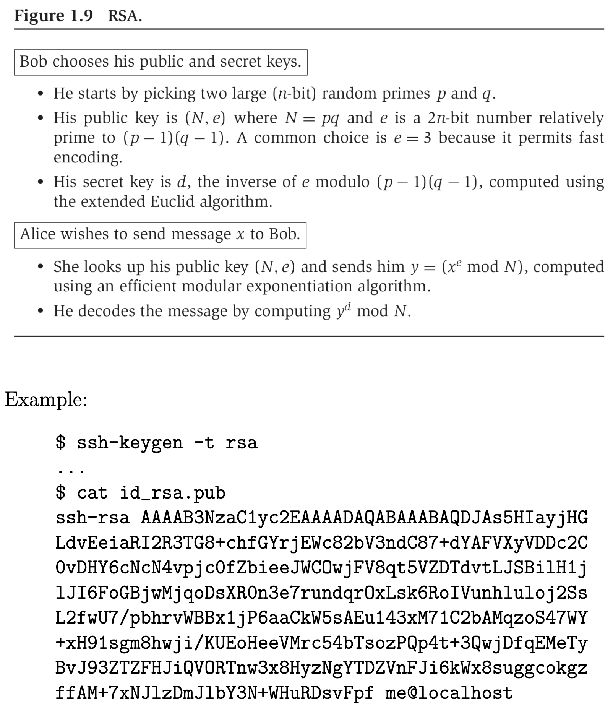

# Universal Hashing, Divide and Conquer

## Universal Hashing

### Example

University of Waterloo has data about students that looks something like:

|  |  |  |  |  |  |  |
| --- | --- | --- | --- | --- | --- | --- |
| **Student ID** | Last Name | First Name | Degree Objective | Date of Matriculation | Term 1 + Marks | … |

The Student ID is used to uniquely identify each student record. We call it a *key*. The remainder of the data for each student is called *satellite data*. The school seeks to store this data and retrieve it efficiently. Assume that is the data structure that stores all the data. For any given student record, , there is an efficient function , which returns the key, i.e., Student ID, associated with .

* : Creates a new, empty instance of and returns it. May take arguments, e.g., the space allocated to .
* : Insert the record into . If a record with already exists in , adopt some convention, e.g., replace it with this new one.
* : Remove the record associated with key in . If such a record does not exist, adopt some convention, e.g., leave unchanged.
* : Return the record associated with key from . If such a record does not exist, return a special string, e.g., .

What data structure, and associated algorithms, will you choose for ?

Answer: It depends on: how frequently is invoked compared to and/or , how much space is allowed to take, how efficiently needs to run.

### Two Possible Candidates for

Array, indexed by Student ID:

* Good: runs in time .
* Bad: Space inefficient. .

Linked List:

* Good: Highly space efficient.
* Bad: runs slowly.

### Hash Table Objectives

* Time Efficiency: to run in time .
* Space Efficiency: If we seek to store records, space we should have to allocate .

### Problem Setup

* We have a universe of keys, .
* We seek to store records each with a unique key. Typically, .
* Designer of hash table knows: , and , to some approximation.
* Designer of hash table does not know how the keys are chosen from .

### How a Hash Table Works

* Designer picks some space allocation, . Typically, . Each is called a bucket.
* Designer picks a *hash function*, : .
* Designer picks a strategy for *resolving collisions*.
  + Two distinct keys, are said to collide under if .
    - Collision guaranteed if .
    - Can be much worse: if , there exists a set of keys with that all hash to the same bucket, immaterial of choice of .
  + We consider collision resolution by *chaining* only.
  + If two records with keys need to exist in the hash table, and , then we maintain a linked list of the records in the bucket .

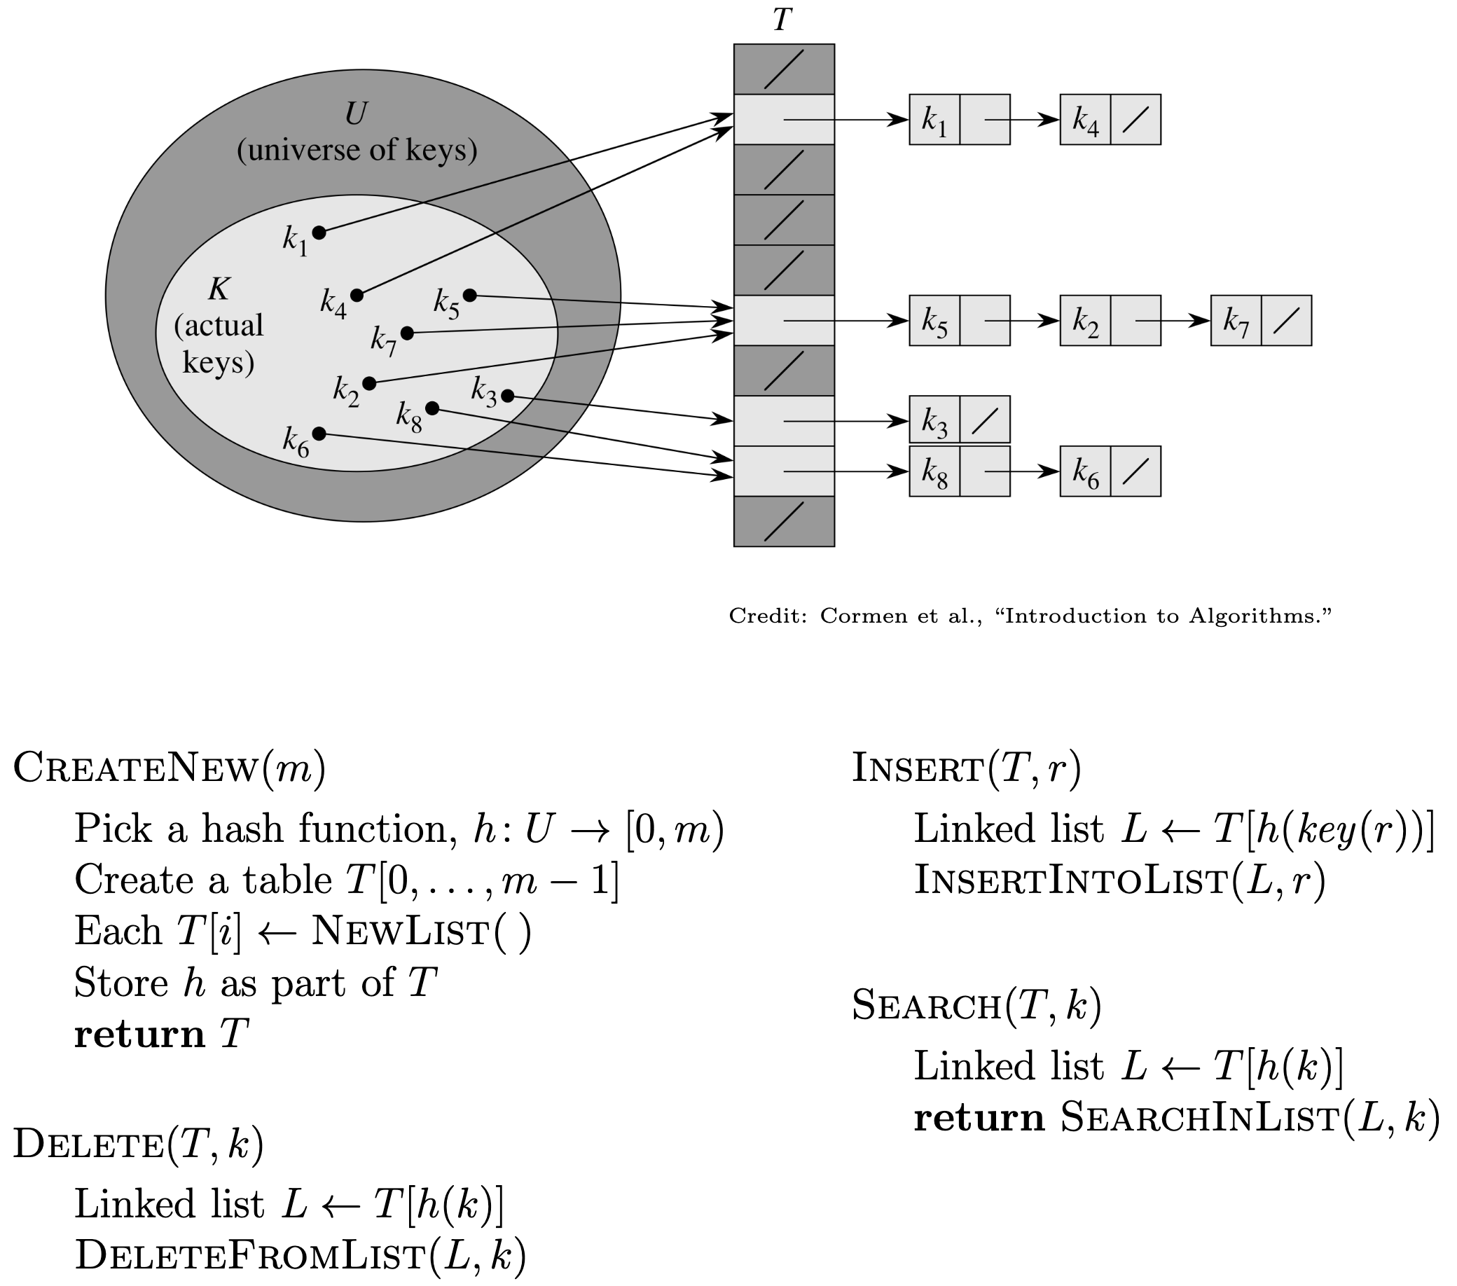

Choice of is critical to performance. What is an “ideal” ?

* Can be computed in time constant in .
* Minimizes collisions. More precisely, acts like a “random function.”
  + Suppose for all distinct .
  + Then in expectation, .
  + Then, if , expected time for is .
  + Note: Worst case time for remains .

### Universal Hashing

Given and , construct a set of hash functions with the following property:

Given any two distinct , the number of hash functions in for which and hash to the same bucket is .

Then, in , pick an from uniformly at random.

**Claim 1:** *Given a universal set of hash functions, , if we pick uniformly at random, then for all distinct .*

*Proof.*

Challenge: How to construct such an given .

### How to Construct Given

We use Student ID as keys: .

Now construct as follows:

* Generate some prime such that .
* For , let .
* Adopt .

Observation right off the bat: .

For the following claims, adopt:

* .
* chosen uniformly (at random) from their respective sets.
* .

**Claim 2:** .

*Proof.* , and neither nor . And so, .

**Claim 3:** *Let:*

*Then:*

*Proof.* *

Therefore, , a contradiction.

*\*Example:* and

These are both linear equations with unknowns . Now, are between and , and since is prime, is relatively prime to , and so its multiplicative inverse exists.

Thus, for distinct :

* Each distinct maps to distinct
* In each such .

Now:

* .
* .
* So to mapping is one-to-one.
* So, picking uniformly is equivalent to picking uniformly.

Finally, the part:

* Suppose each of is chosen uniformly at random.
* Then, for chosen uniformly.

To intuit the term, pictorially:

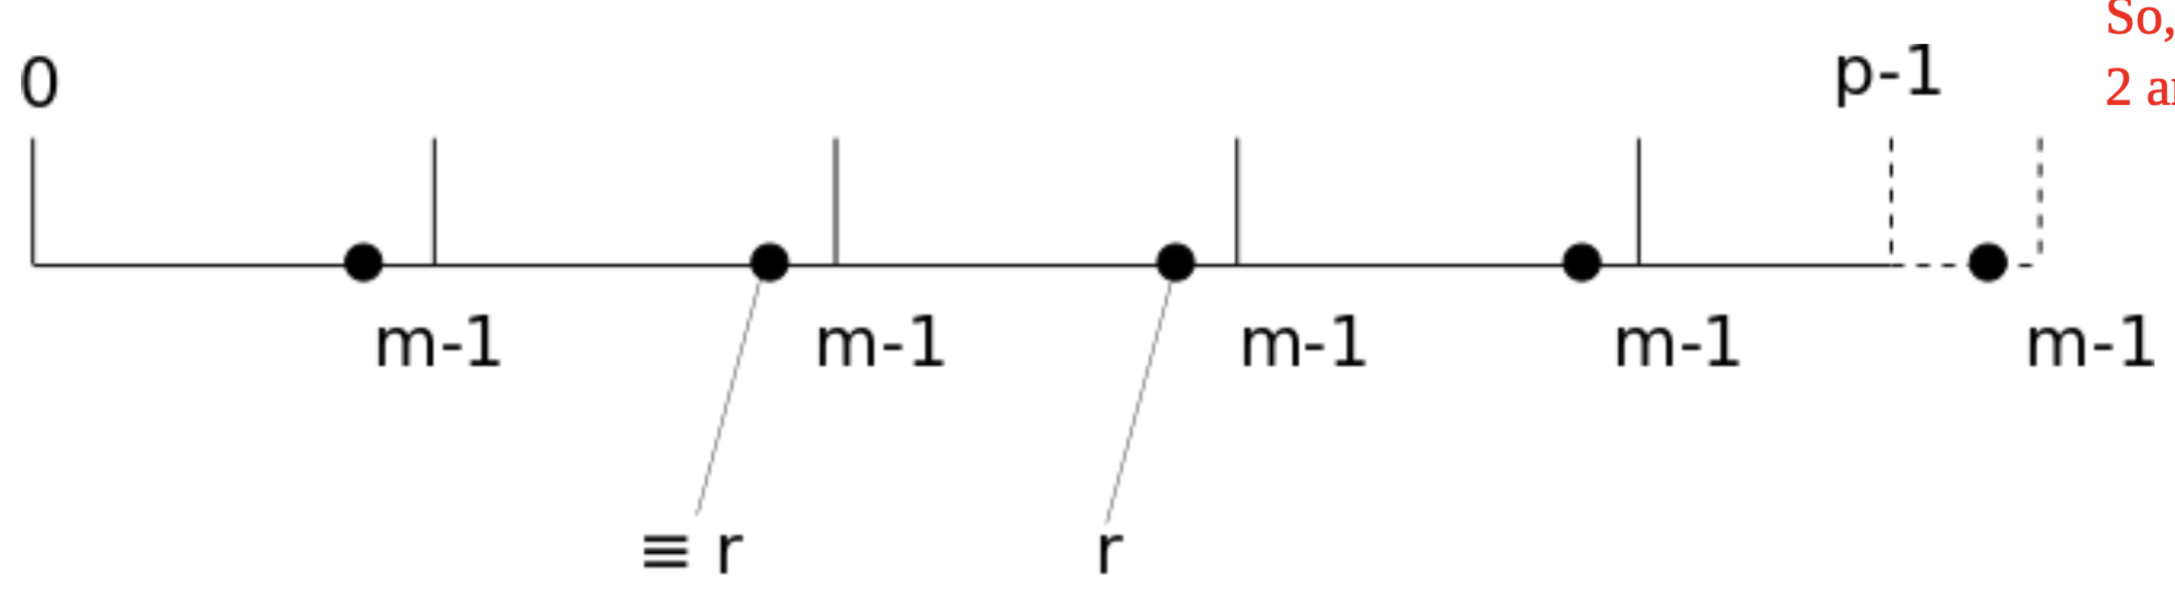

*In the figure, . The value , and every member of , but is shown as a bold dot.

And we know that . So:

*\*Example:* .

Then, .

So, in the set , the two numbers, and , are congruent modulo : .

## Divide and Conquer

### Definition

**Divide and Conquer:** An algorithm design strategy to which some problems lend themselves.

The *divide and conquer* strategy solves a problem by:

1. Breaking it into *subproblems* that are themselves smaller instances of the same type of problem
2. Recursively solving these subproblems
3. Appropriately combining their answers

Example: Compute the product given .

Assume our encoding is binary. First split the bits of each into the leading half the bits and trailing half the bits. E.g., .*

Then:

\**Example:* In base 10, e.g.,

So, to compute , where each is bits:

* Three multiplications of numbers bits long
* Two left bit shifts, one of bits and the other of bits
* Six additions/subtractions each of bits

Recurrence for running time, :

To solve the recurrence, draw a recurrence tree, which is equivalent to inductive “string rewriting” as follows.

First, for the term, we adopt a canonical function, , and for , we adopt .

: For what is ? Answer:

: , , then exponentiate by :

:

Subtract:

Implies:

### Solving Recurrences

Suppose we have the following recurrence for a function , with constants :

**Claim 1 (Master Theorem):** *Given as in the recurrence above,*

*Proof.* Draw a tree and count.

Example 1: Binary search on array of items. Running time, , as measured by # comparisons of items in the (sorted) input array and the item we’re searching for:

We have . So, , and .

Example 2: Recurrence for our algorithm for multiplication.

We have . So, , and .

### Sorting Problem

Given as input an array whose items are drawn from a totally ordered set, return the sorted permutation of .

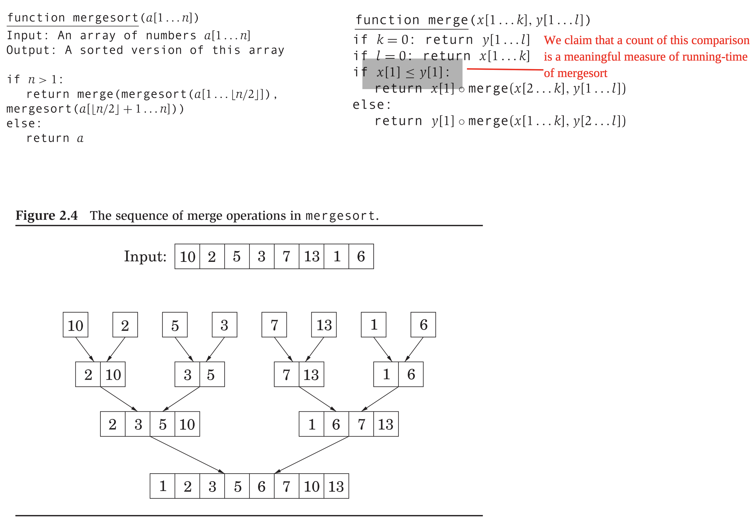

**Claim 2:**  *is correct.*

*Proof.* Induction on .

**Claim 3:**  *is correct.*

*Proof.* Induction on . Appeal to Claim 2.

.

**Claim 4:**  *is optimal in the # comparisons: any comparison-based sorting algorithm performs comparisons*.

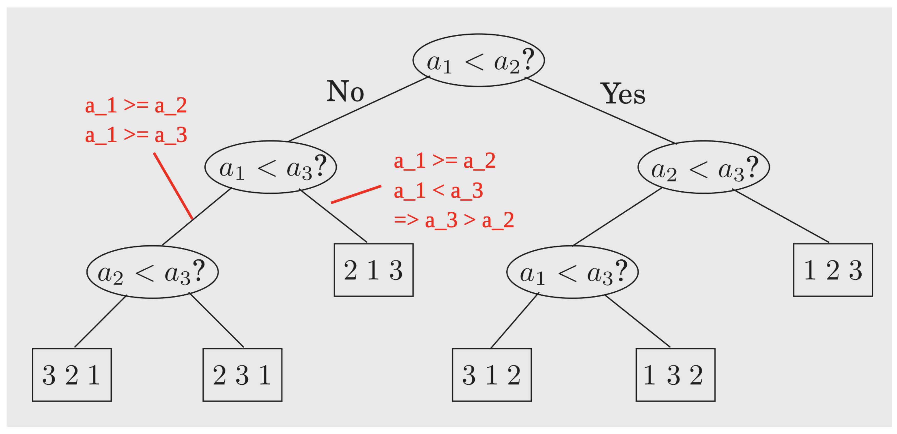

* What is the most compact way possible to consider every possible permutation? Where “way possible” refers to pairwise comparisons.
* Answer: Binary tree as shown above, with every permutation showing up as a leaf.
* Minimum # comparisons (in worst case) longest path from root to a leaf .
* One of the rare instances in which we have a lower bound for an algorithmic problem.

## Divide and Conquer Applications

### Selection Problem

Given as input: an array of items drawn from a totally ordered set, and an integer , identify the smallest item in .

E.g., if , we seek the smallest. If , we seek the largest. If , we seek the (left) median.

A divide and conquer strategy:

* Pick some member of as the *pivot*, .
  + E.g., randomly from amongst all items in .
* *Partition* or *split* around that pivot .
  + Rearrange items in as follows:
    - Move every item to the left of .
    - Move every item to the right of .
    - Thus, every item whose value is ends up where it would in a sorted permutation of .
* Check and recurse.

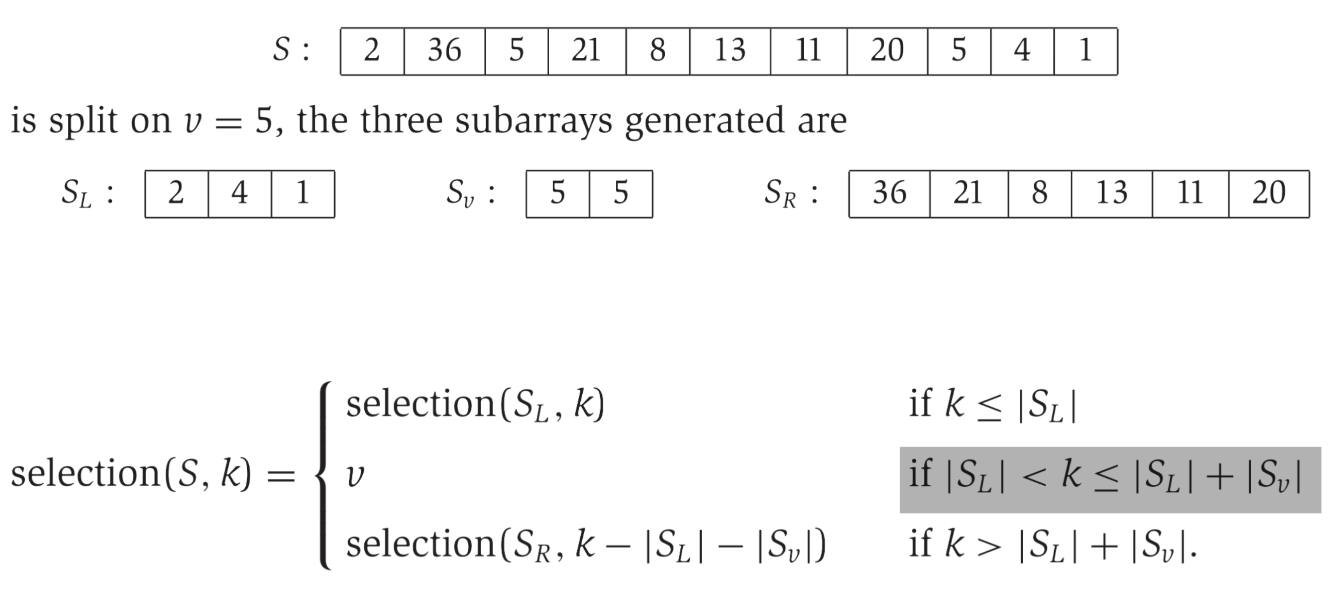

If chosen to be, e.g., median, then .

Challenge is now: How to guarantee a good choice for ?

Suppose “good” is some value in the middle of .

* E.g., if , .

Then, recurrence for running time of :

To pick such a “good” :

* Pick random .
* Check if it is good: .
* If not good, repeat.

So # trials in expectation to get a “good” ,

So, we have an algorithm for , which runs in time in the expected case.

### Matrix Multiplication

Given two matrices, , compute the product .

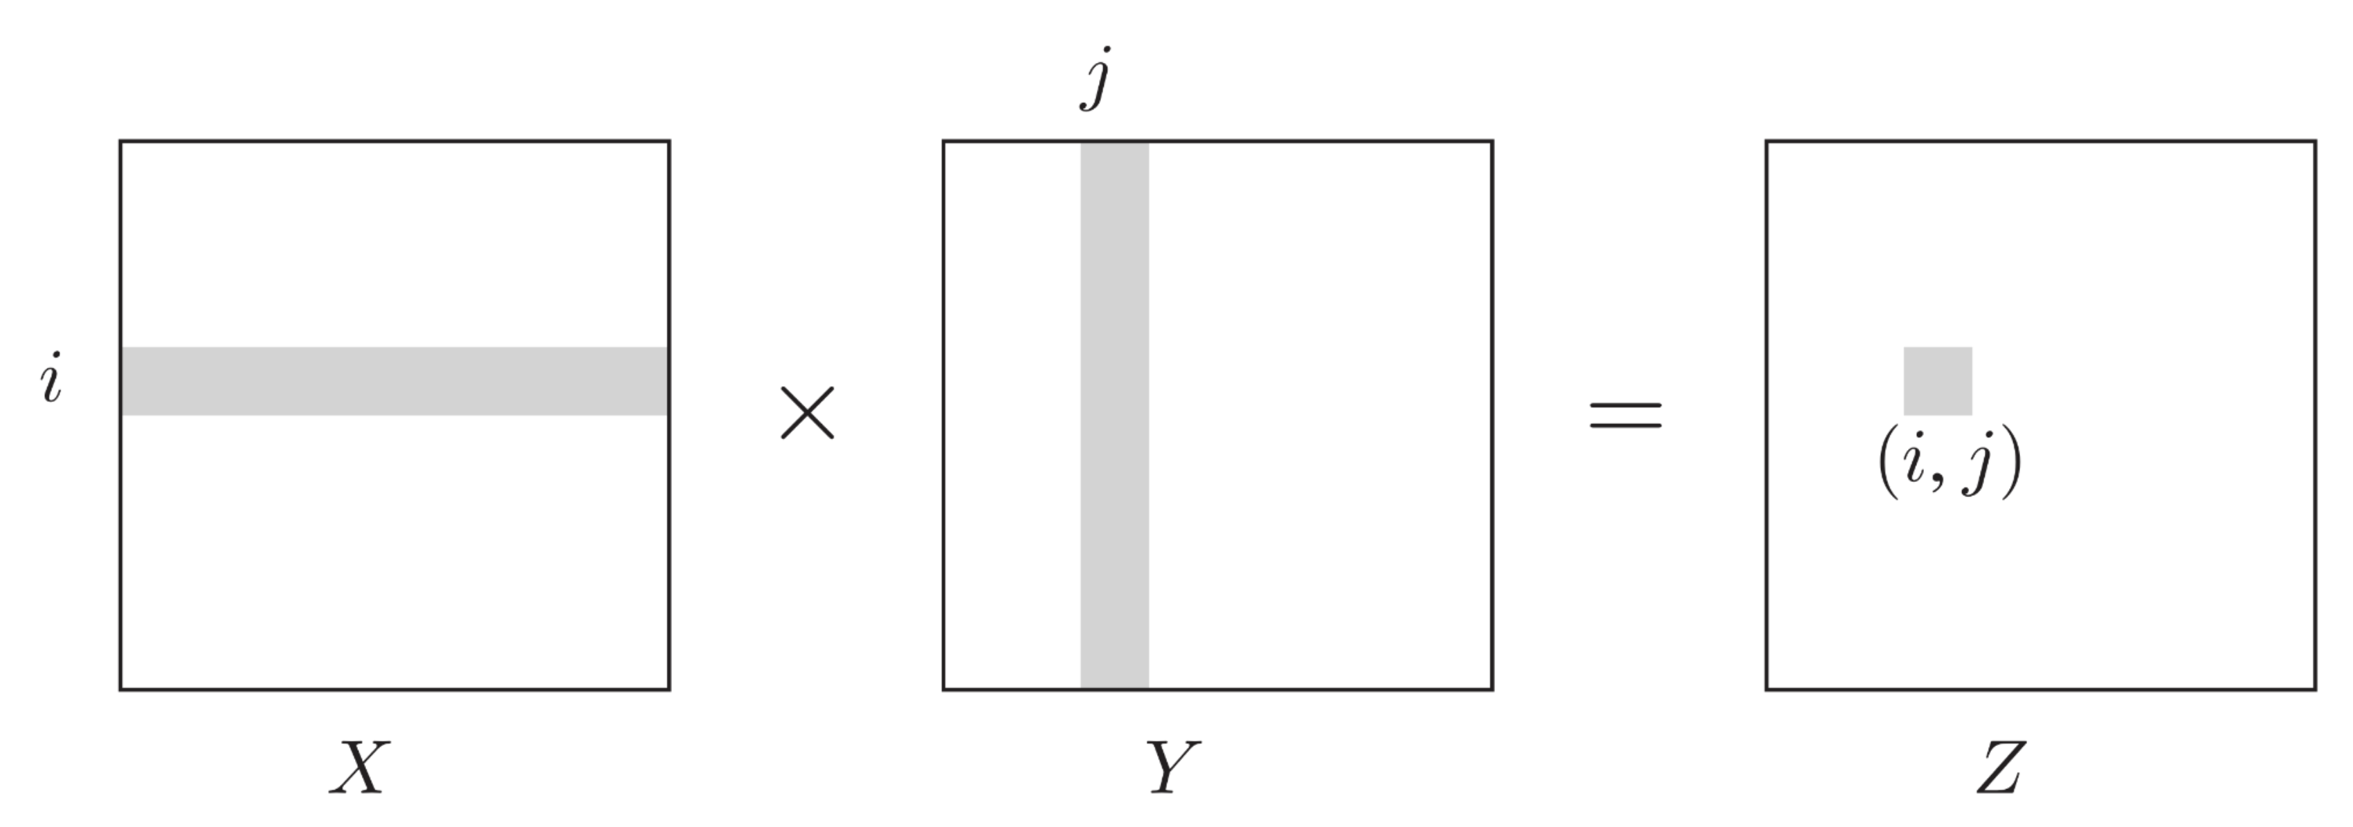

Naïve algorithm to compute scalar multiplications and additions.

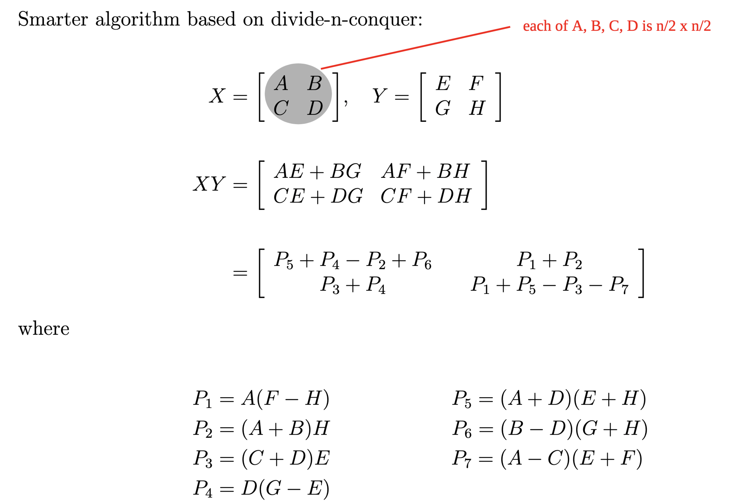

Now, recurrence for # scalar multiplications and additions:

# Decompositions of Graphs, Paths

## Graphs

Graph . . .

* Directed: . Written .
* Undirected: . Abuse notation and write .

Lots of things are modelled using graphs. E.g., maps, digital circuits, social networks.

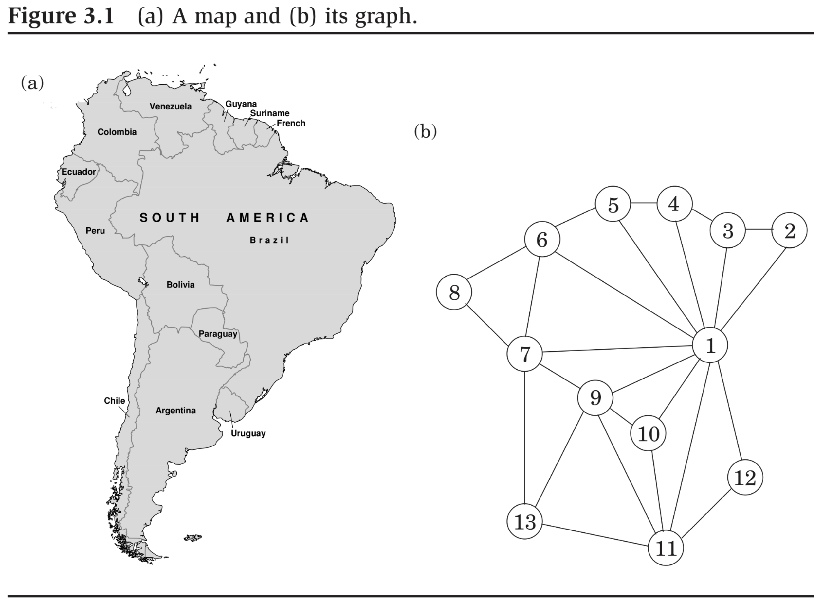

### Representing a Graph

Adjacency list and adjacency matrix.

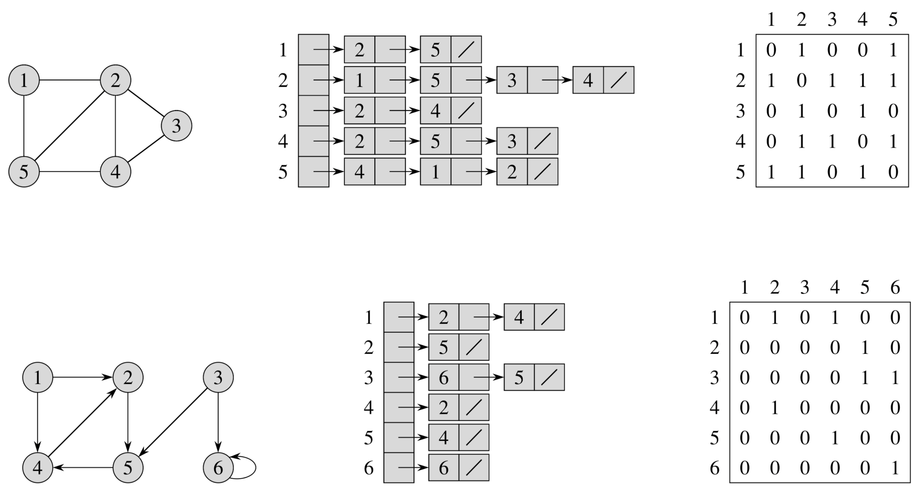

### Graph Exploration

An encoding of a graph can be seen as local information, i.e., just information about adjacency. Algorithmic problems with graphs ask about some global property of the graph.

Given a graph and two distinct vertices , is reachable from ?

An algorithm for this: Depth-First Search (DFS).

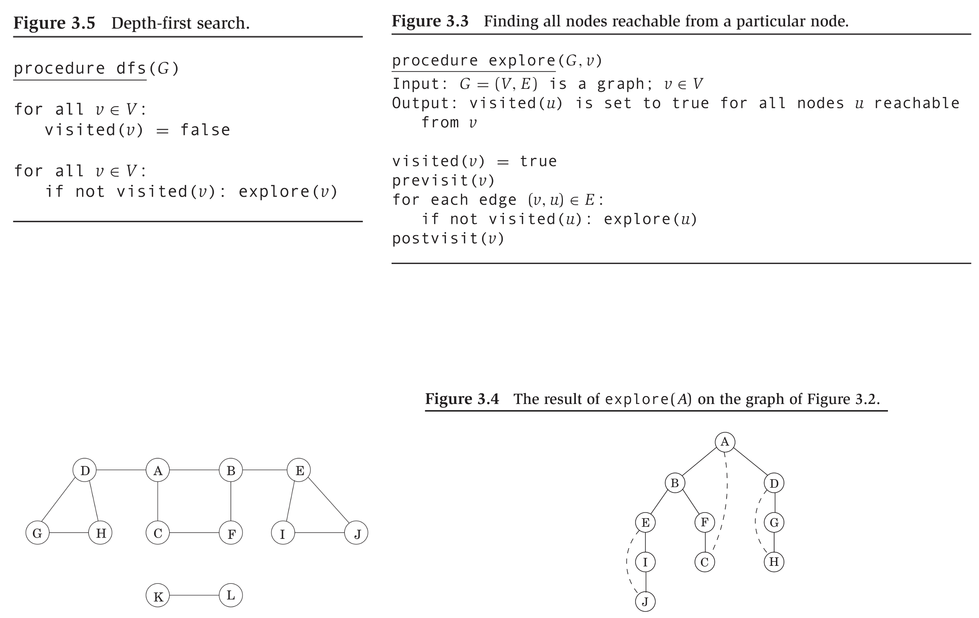

**Claim 1:**

Time efficiency: .

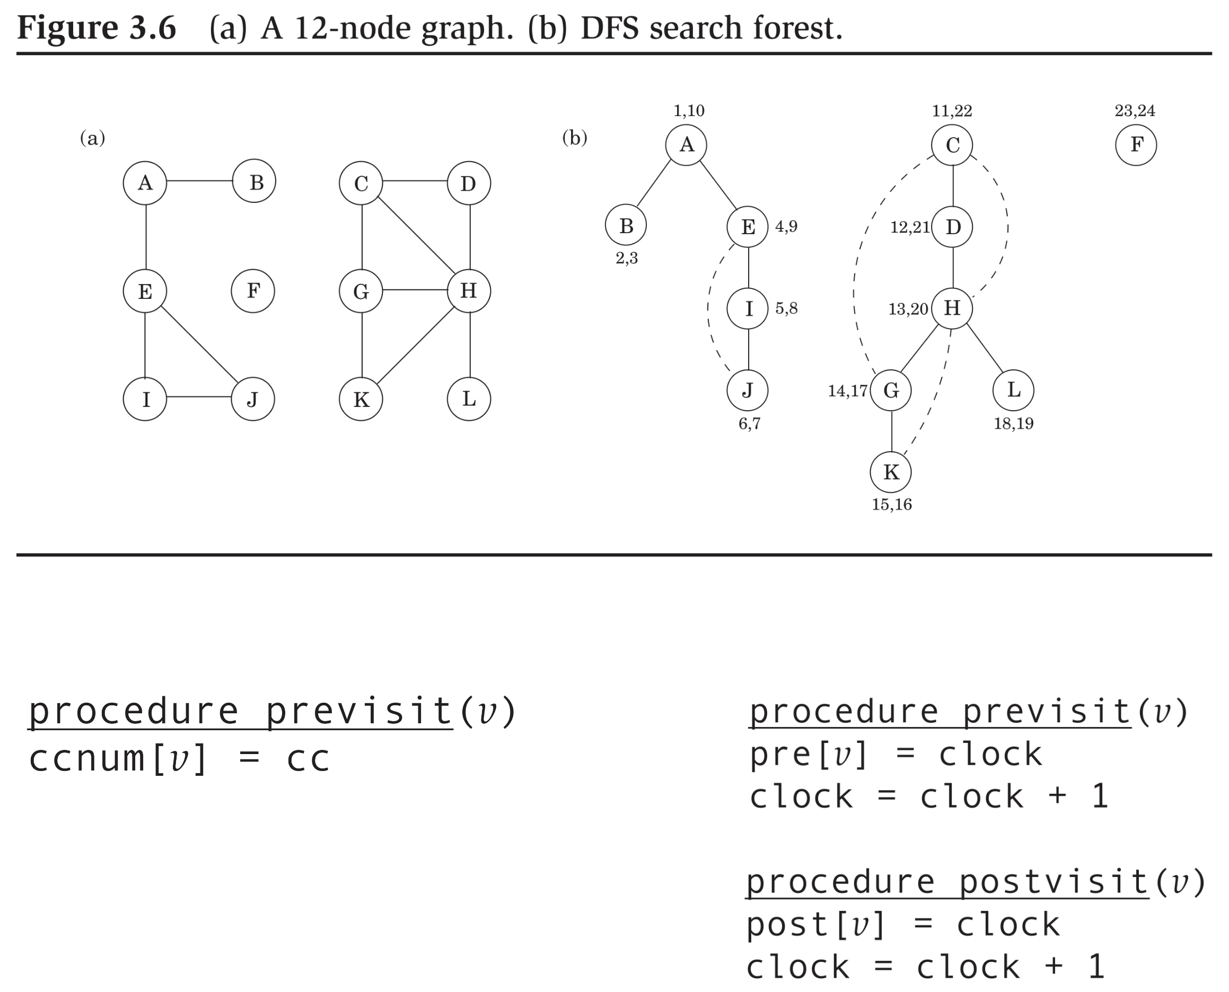

## DFS, Continued

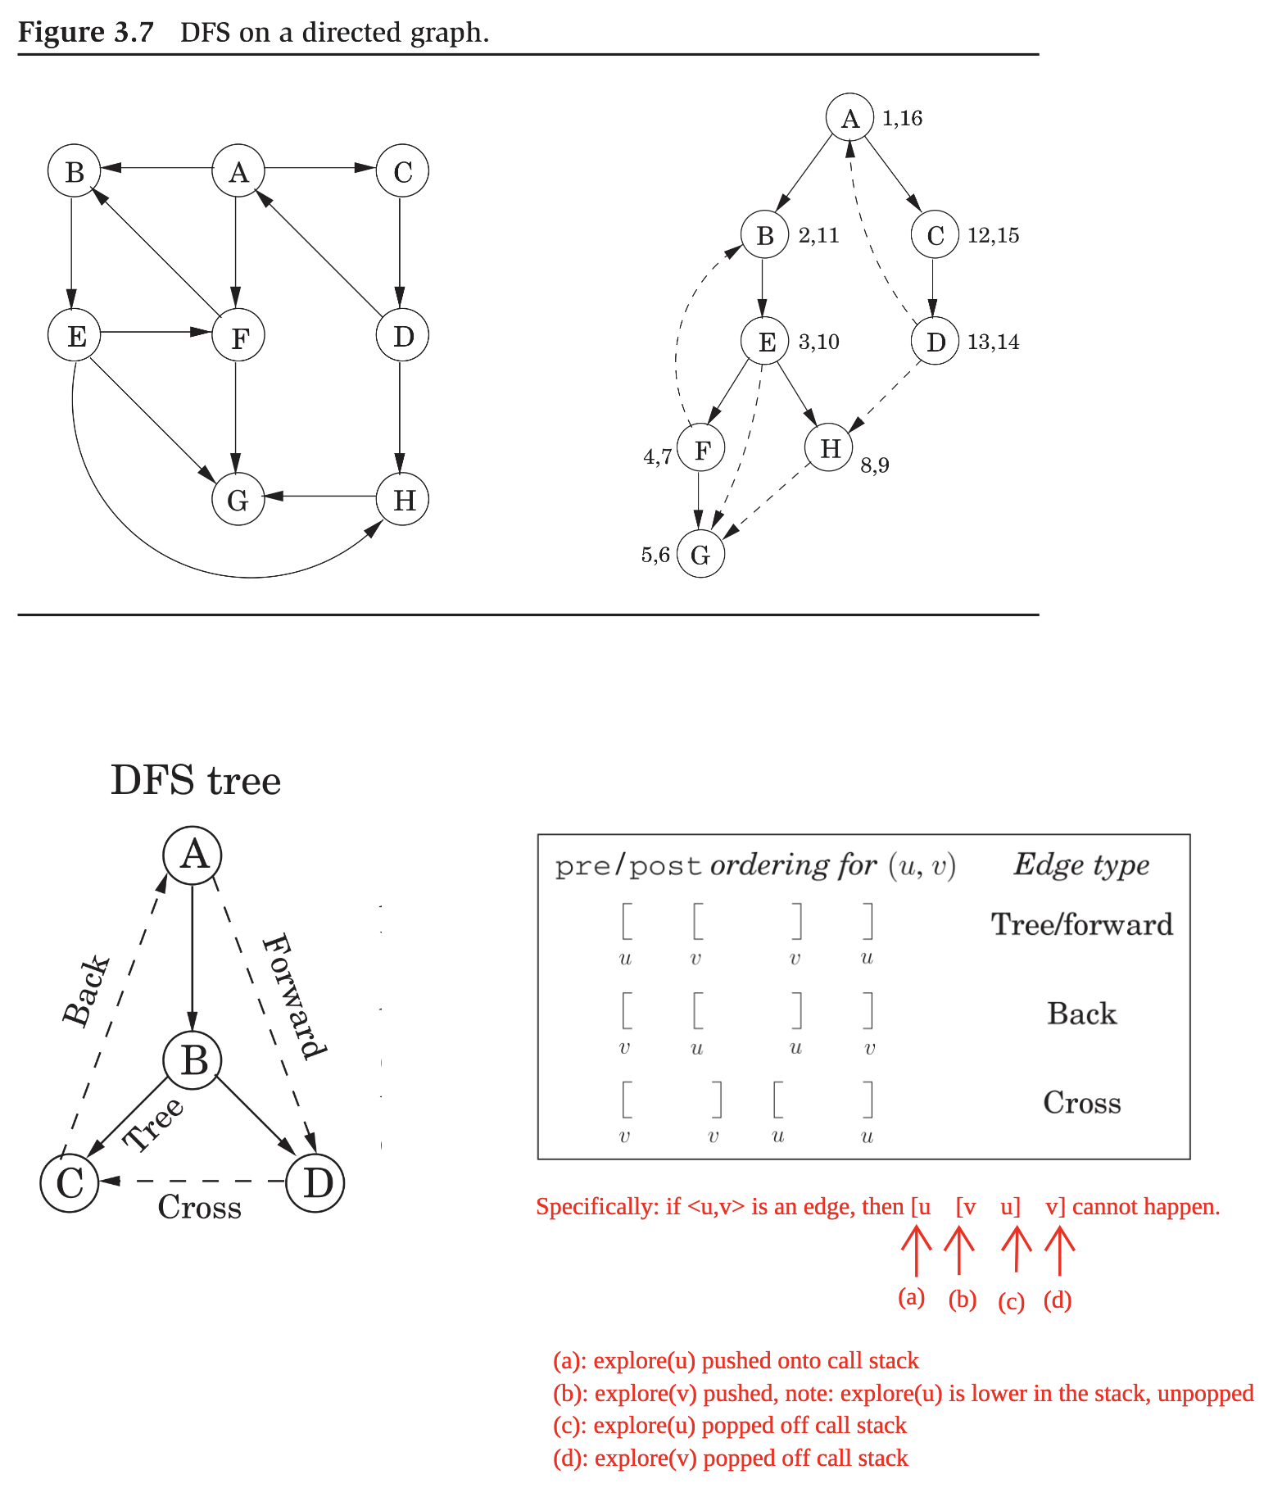

### Directed Acyclic Graph (DAG)

Linearization or topological sort: of a DAG is a left-to-right ordering of all the vertices, such that , i.e., all edges go left to right.

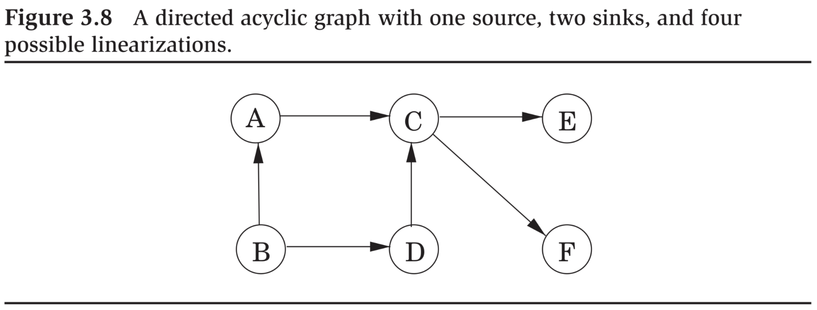

A linearization: .

**Claim 1:** *If is a DAG, then in a run of , every edge leads to a vertex with a lower (i.e., smaller-valued)* **post** *number*.

Equivalent to: if is a DAG, then in any run of , no edge is a back edge.

An algorithm for linearization:

*Run*

*When we are done with a vertex, insert it at the beginning.*

**Claim 2:** *Directed is acyclic if and only if it is linearizable if and only if results in no back edges.*

Another algorithm:

*Find a source, output it, and delete it from the graph.*

*Repeat until the graph is empty*.

Claim: This algorithm runs in time as well.

### Strongly Connected Components

Given directed with are said to be strongly connected if and .

Given directed , the set of Strongly Connected Components is a partition of with the property: for all , distinct and .

Recall: A partition of a set has the properties: for all , and for all distinct , and .

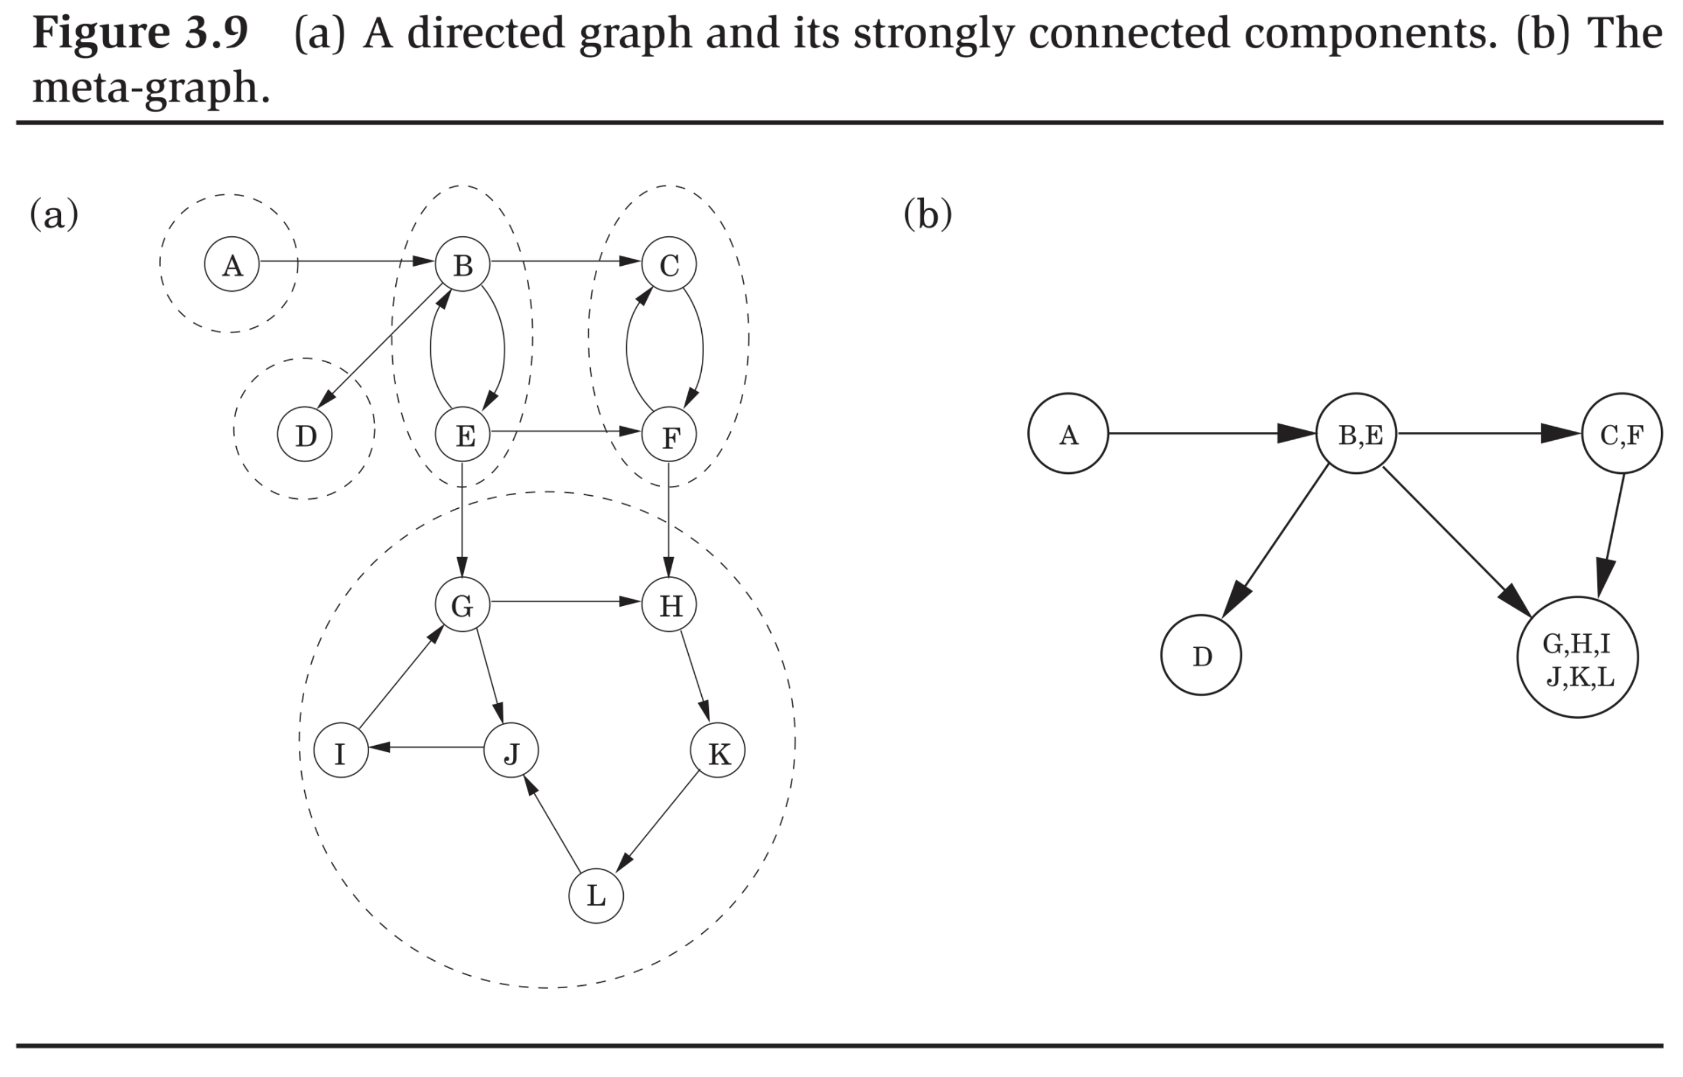

**Claim 3:** *The meta-graph is unique, and acyclic*.

The algorithm for computing the meta-graph:

1. *Run on .*
2. *Run the undirected connected components algorithms on , and during the depth-first search, process the vertices in decreasing order of their* ***post*** *numbers from Step (1)*.

Where is the *transpose* or *reverse* graph of .

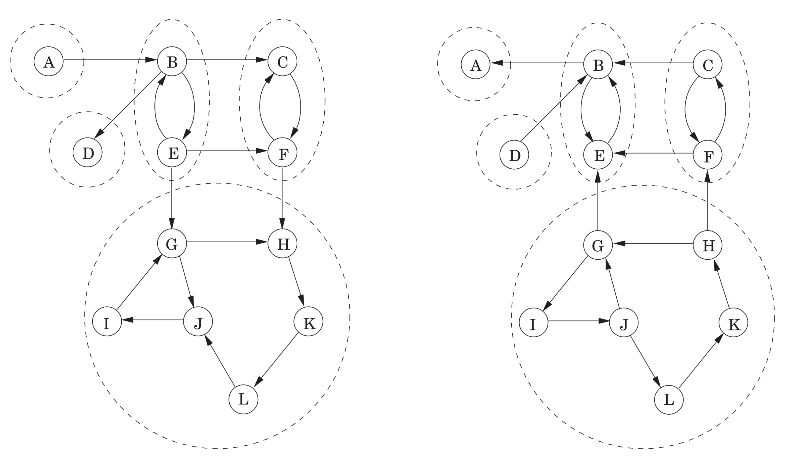

**Claim 4:**  *can be computed from in time* .

**Claim 5:**  *is a SCC in if and only if is a in* .

**Definition 1:** *In a directed graph is called a source if there is no edge that is incident on . A node is called a sink if there is no edge that leaves* .

**Claim 6:** *A node is a source in if and only if it is a sink in . A node is a sink in if and only if it is a source in* .

*Proof*. Exploit the sub-claim: .

**Claim 7:** *A node that receives the highest* ***post*** *number in a run of on a directed graph lies in a source in SCC of the meta-graph*.

* And therefore, a sink SCC of .

**Claim 8:** *If are distinct SCCs in , and there’s an edge where , then the highest* ***post*** *number in is bigger than the highest* ***post*** *number in in any run of on* .

* A generalization of Claim (7) above.

Step (1) of the algorithm on example above can result in: .

Then, Step (2) may group, in sequence: .

Sanity-check question: if that was the sequence of **post** numbers in Step (1), which vertex happened to have been chosen first in ? More generally, what was the order of vertices chosen in ?

* Solution: Work backwards from the last one, i.e., .
* First vertex chosen was . Then . Then . Then . Finally, .

## Shortest Paths

* Another “global” property in the context of a graph.
* A path (of length ) in is a sequence where for all . A path is simple if all vertices in it are distinct.
* A shortest path from vertex to is one of minimum length across all paths . We call the length of the shortest path the distance from to .
* A shortest path is not necessarily unique. The length of a shortest path is.

**Claim 1:** *If a path exists, then a shortest path exists. If a shortest path exists, it must be simple*.

### Breadth First Search (BFS)

* An algorithm to compute distances and shortest paths from a source vertex.
* Mindset: Think of edges as cloth strings of equal length. A BFS tree results from picking the graph up by the source vertex.

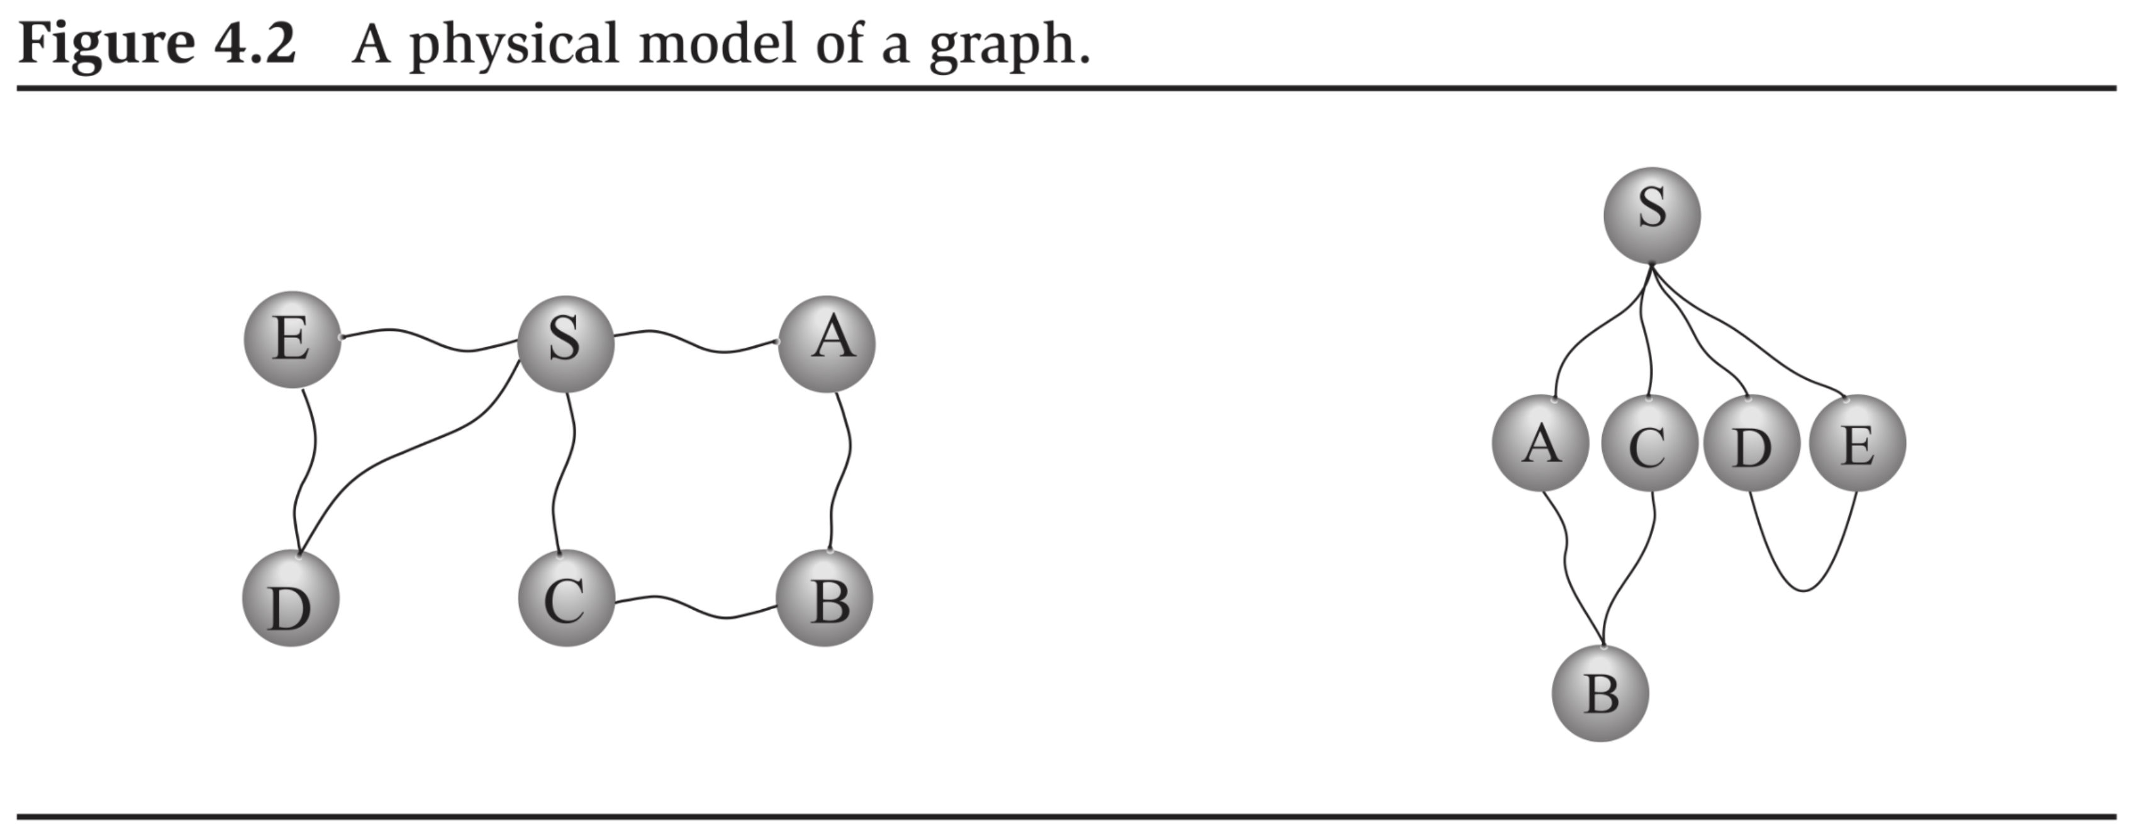

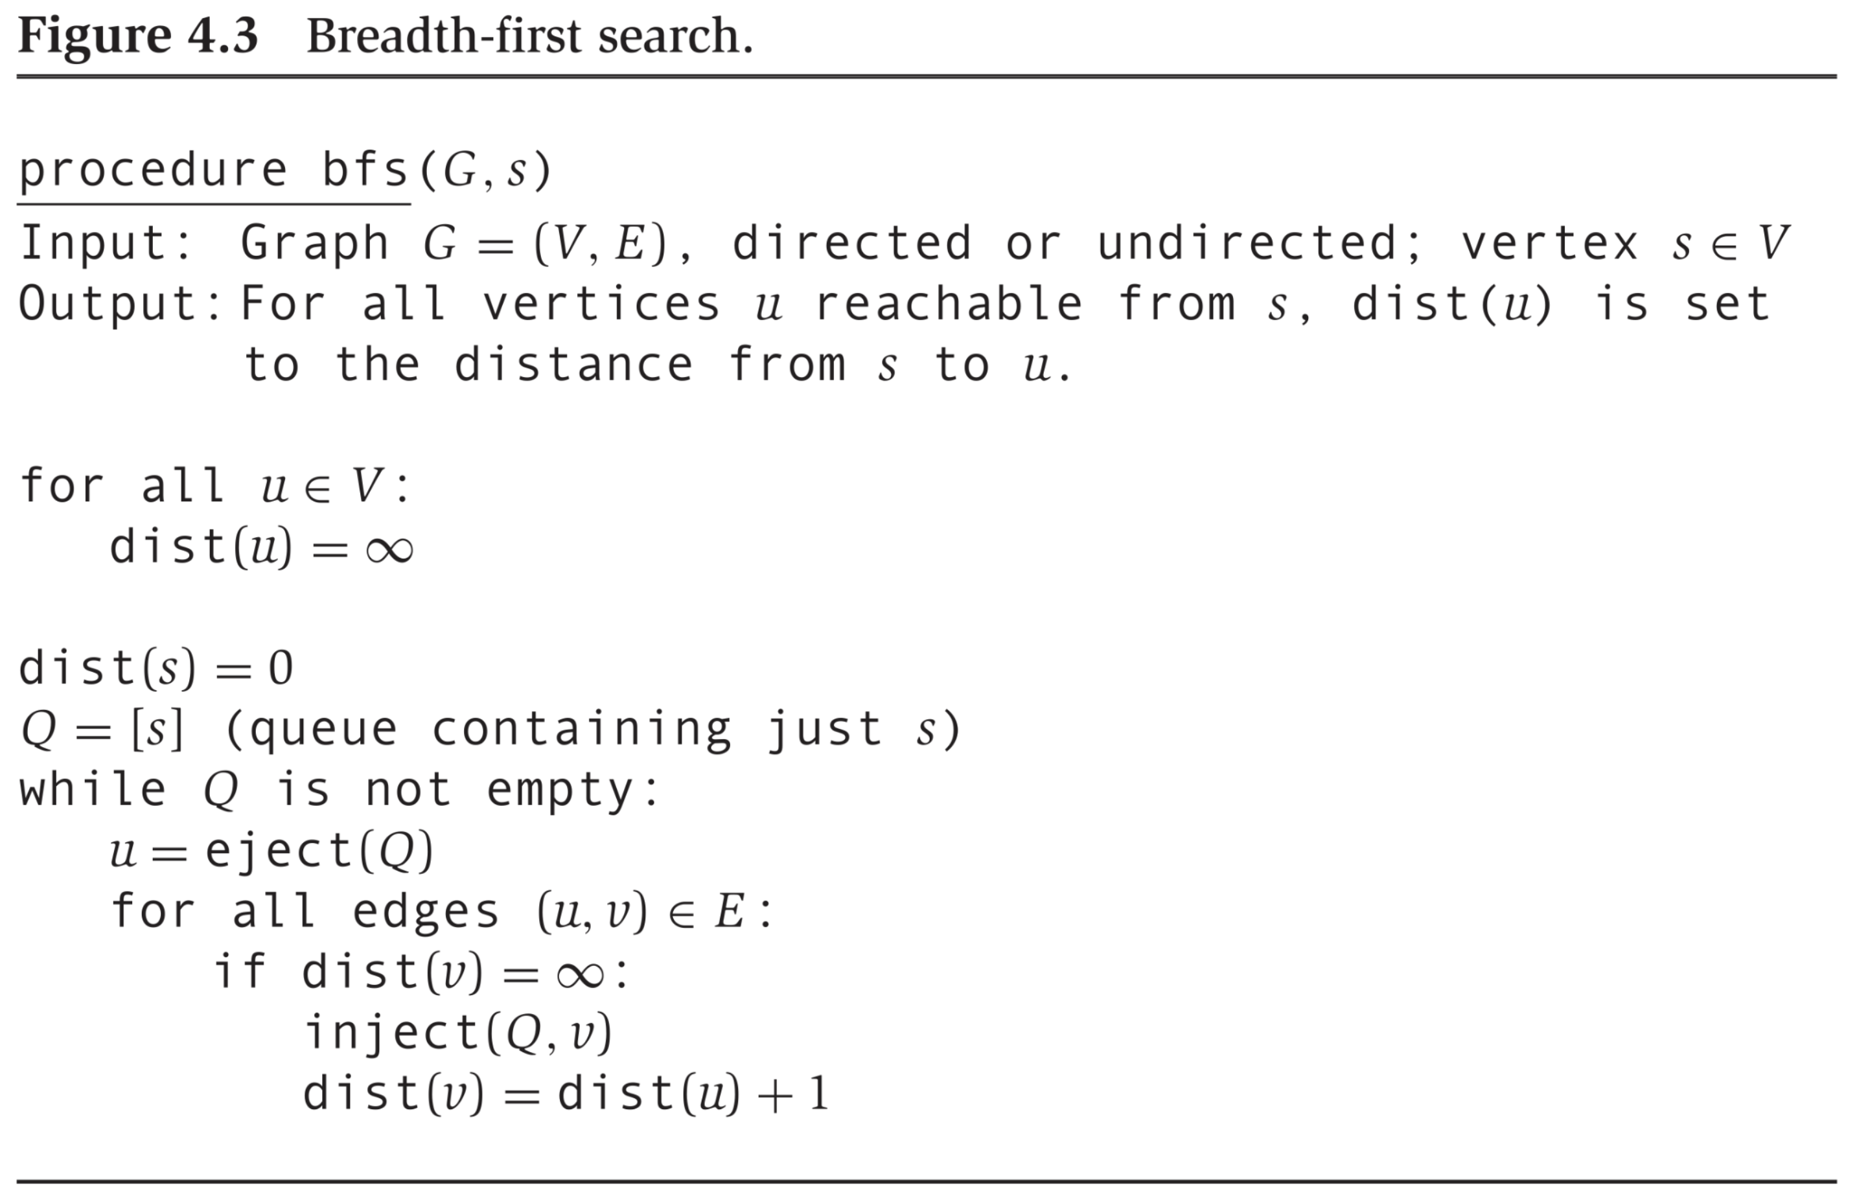

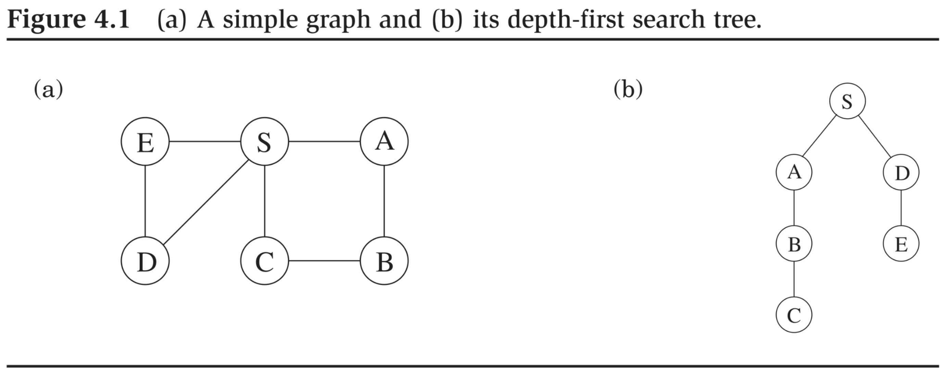

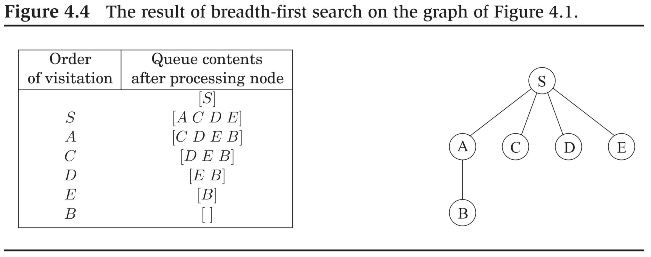

Correctness of BFS:

**Claim 2:** *For every , results in the correct value for* .

*Proof*. Two cases.

1. No path exists. Then, for BFS to be correct for that particular , at the end of the run of the algorithm.
2. If a path exists, then let be the distance from to . Then prove by induction on that . Use the fact that , once initialized, is then set only when is enqueued, and never again thereafter.

Time efficiency of BFS: .

Unlike the manner in which we designed DFS, not every vertex and edge is necessarily visited by BFS. So, its time efficiency is in the worst case only.

# Paths in Graphs, Continued

## Shortest Paths in Weighted Graphs

We now assume that a graph is a triple , where .

Suppose for all . Then, a candidate algorithm:

*Introduce “dummy” vertices on edge .*

*Run* ***bfs*** *on the resultant graph.*

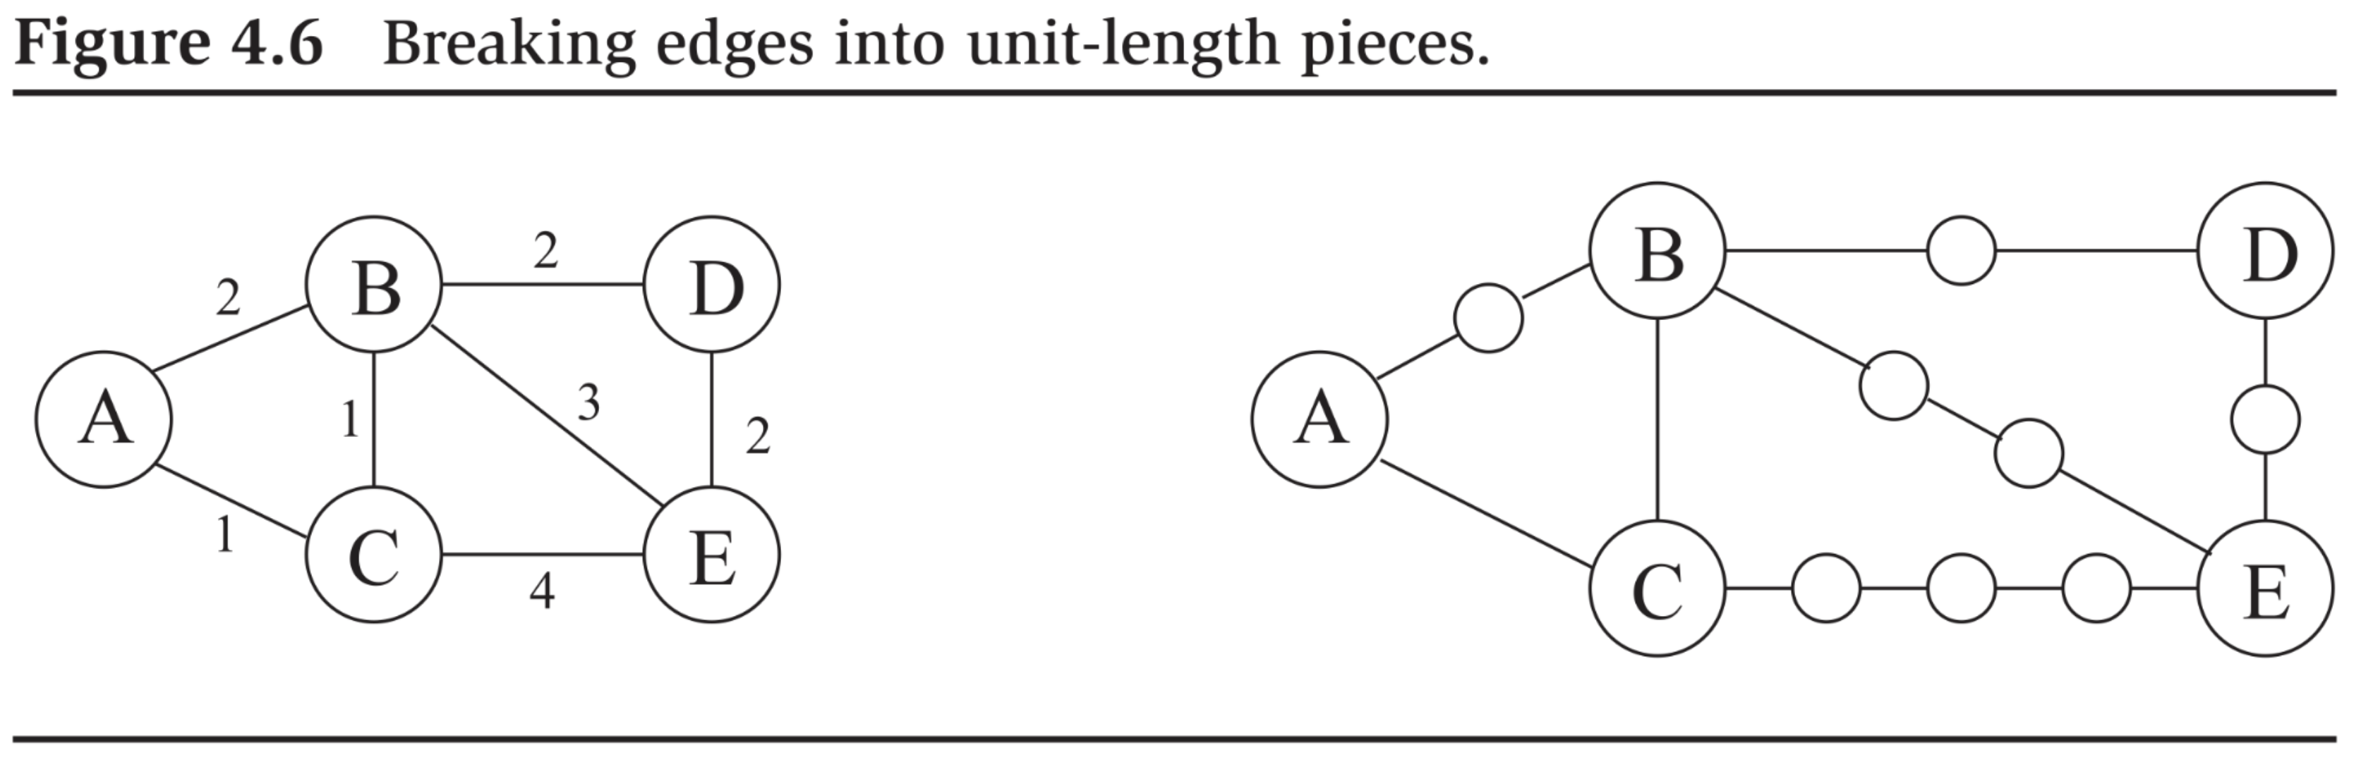

Algorithm is correct, but inefficient. How inefficient?

Answer: In the worst case, algorithm runs in exponential time, i.e., in time exponential in the size of the input.

In binary encoding, each can be encoded with bits only.

Better adaptation of BFS: Dijkstra’s algorithm.

### Dijkstra’s Algorithm

An example of a greedy algorithm: Locally optimal choices result in global optimum.

Caution 1: Not every (optimization) problem possesses such a greedy choice property.

Caution 2: Not necessarily easy to identify such a greedy choice property even if problem possesses one.

Caution 3: Dijkstra’s guaranteed to be correct if for all .

Dijkstra’s assumes access to a priority queue data structure. API:

* : Make a priority queue with a given set of values. May be realized as repeated calls to an algorithm.
* : Remove a queue item of smallest value and return it.
* : Decrease the value of an item in the queue.

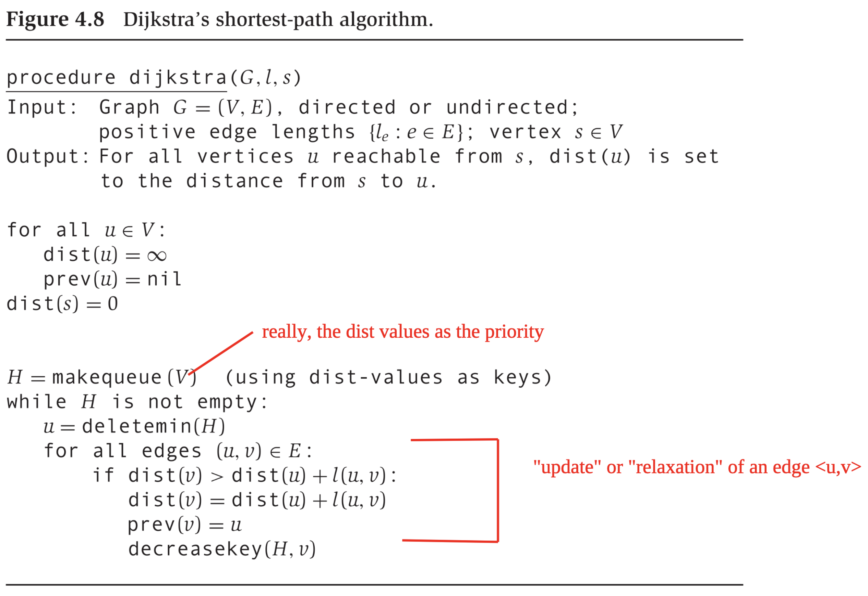

Semantics/properties of “”:

* . Or and .
* For any .
* For any .

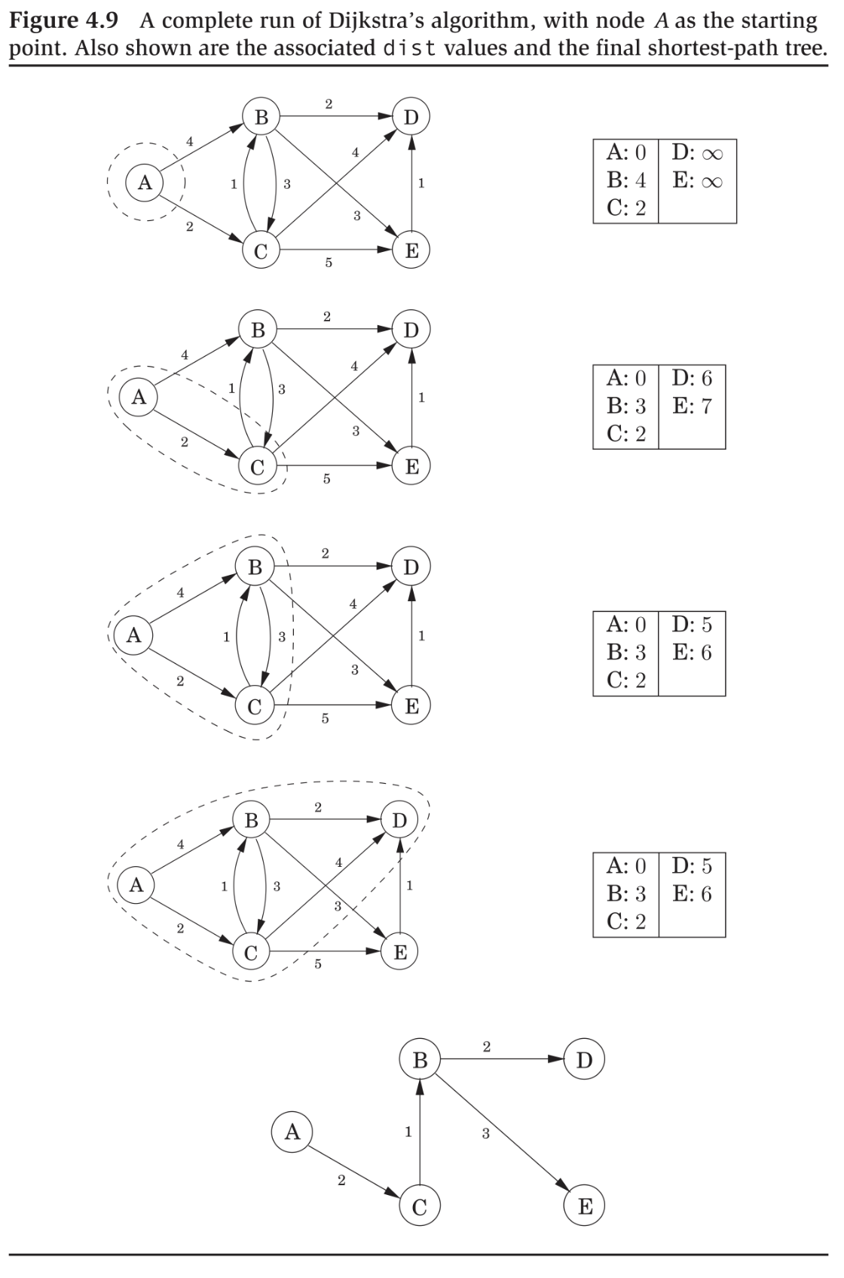

### Correctness

A partial proof. First, denote as the shortest distance from vertex to .

We prove:

*For every vertex that is reachable from , at the moment u is extracted from the priority queue, it is the case that .*

**Claim 1:** If  *is a shortest path from to , then the to subpath is a shortest path from to .*

*Proof.* By contradiction.

**Claim 2:** *Suppose is a shortest path from to , where is an edge. Also suppose that we are at a moment that . And we update based on as in Dijkstra’s algorithm. Then, immediately after, .*

*Proof.* By Claim (1), each of the subpaths and is a shortest path. Therefore, .

**Claim 3:** *Once we initialize to , it is always the case that .*

Note 1: Claims (1)-(3) hold even if we allow negative edge weights.

Note 2: Claim (1) refers to a kind of *optimal substructure*.

Now the proof for the claim about Dijkstra’s:

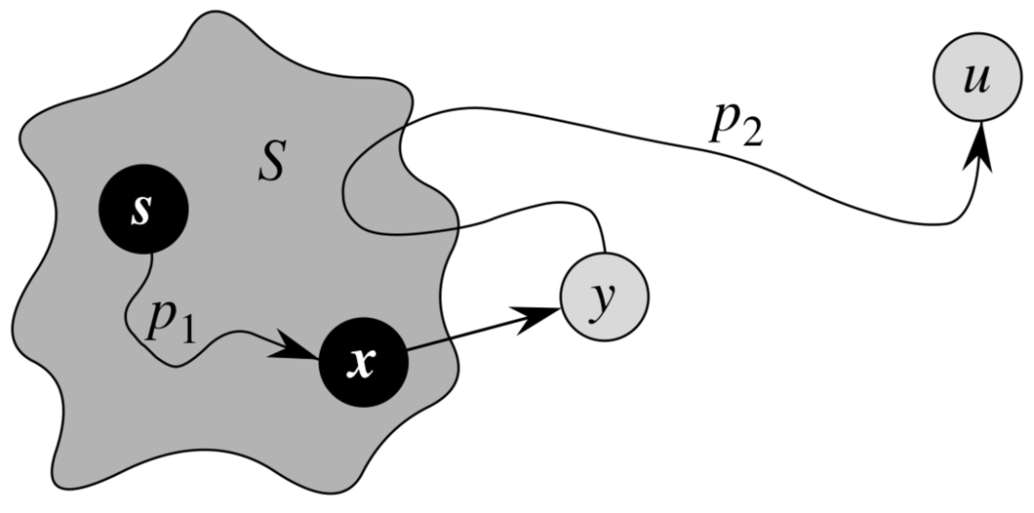

Consider the moment in a run of Dijkstra’s algorithm as shown above.

* The set comprises those vertices that have already been extracted from the priority queue. At the minimum, , but may contain additional vertices. We assume that for every vertex in , its value is indeed correct, i.e., equal to its value.
* We are about to extract the vertex from the priority queue, i.e., its value is the minimum in the priority queue at this moment. For the purpose of contradiction, assume that . That is, is the first vertex in this run of Dijkstra’s for which we have an error.
* Assume that the path shown in the picture is a shortest path from to . That path can be decomposed into: , where: (i) all the vertices of are , (ii) is the first vertex on the path that , (iii) we know , and (iv) it is possible that and/or .

We now derive a contradiction to the claim that .

* – by Claim (2) above.
* – by Claim (1) above, and all edge weights are non-negative.
* – by Claim (3) above.
* – we are about to extract from the priority queue.

So, we have:

We have attained our desired contradiction.

### Time Efficiency of Dijkstra

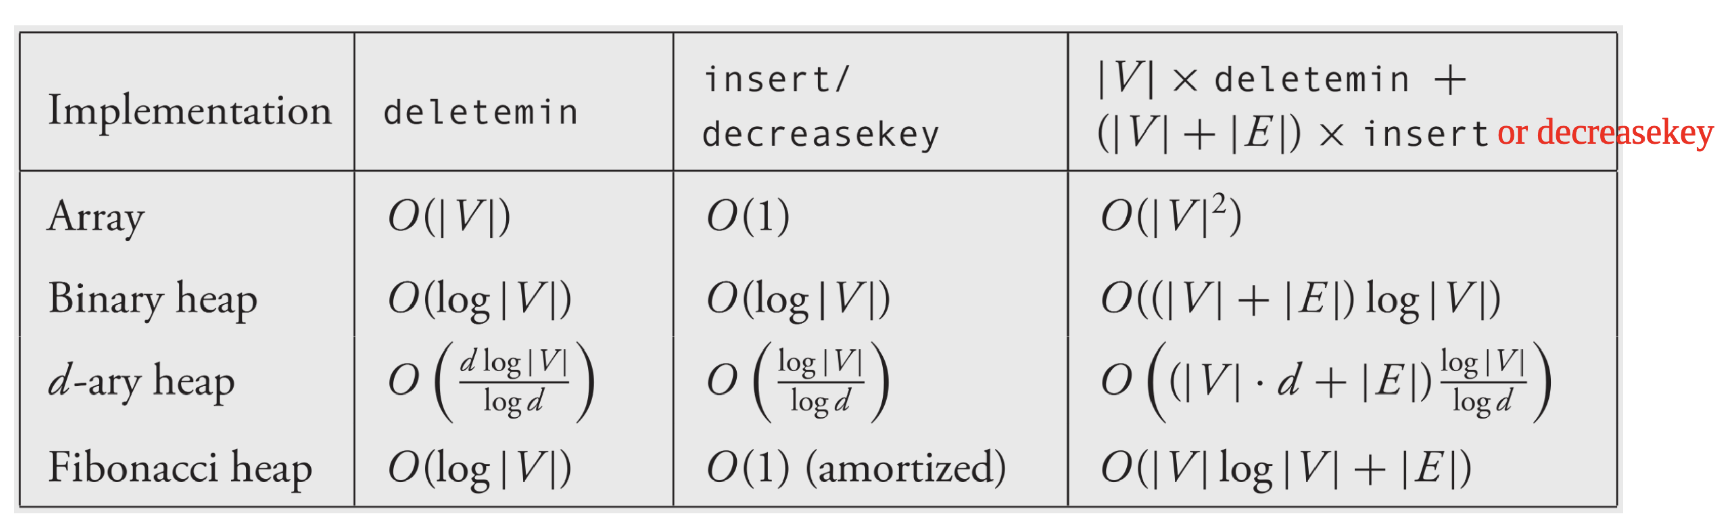

Array implementation:

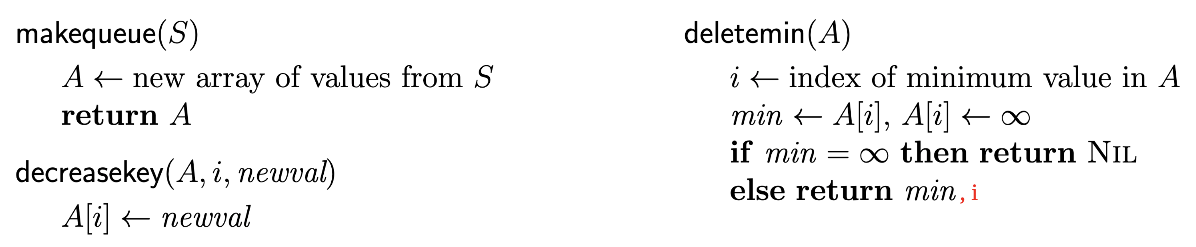

Binary heap:

1. It is a complete binary tree – every level filled from left to right and must be full before next level is started.
2. Key value of any node is the key values of its children.
3. Realization as array : root at index , left child of a node at index at index , right child at index . Parent of node at index is at index: .

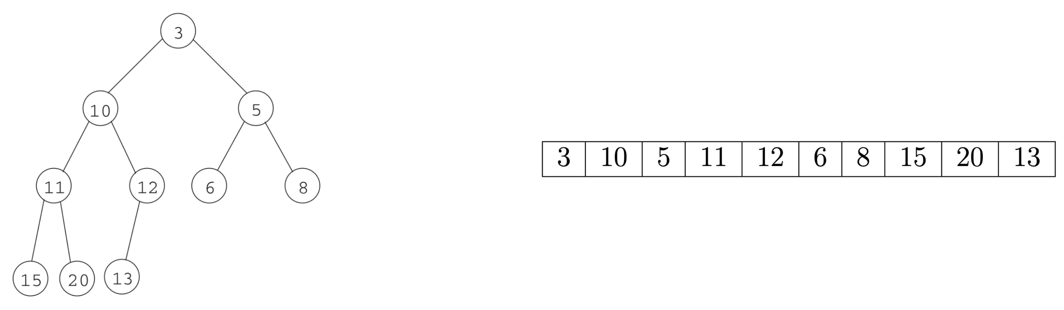

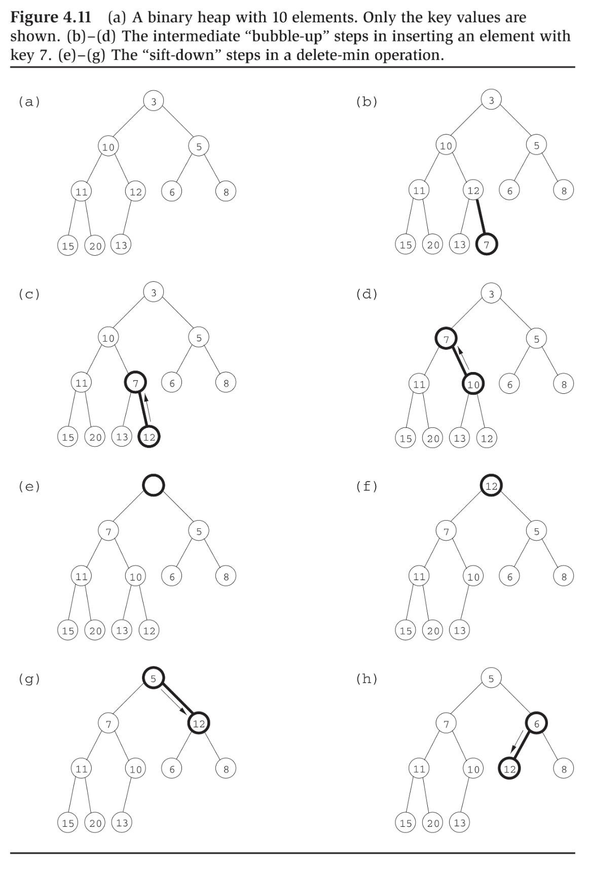

## Shortest Paths and Negative Edge Weights

Dijkstra’s not guaranteed to be correct. If we have a negative weight cycle reachable from source vertex, then notion of shortest path (distance) not well defined.

So, we assume graph has no negative weight cycles (reachable from ).

**Claim 1:** *In a graph that has no negative weight cycles, if there exists a path , there exists a shortest path that is simple.*

Proof by construction: Suppose we are given a shortest path from to that contains a cycle. Just remove the cycle and now we have a path of weight at most the original.

Where proof for correctness of Dijkstra falls apart with negative weight edges:



* Given that the path in the picture is a shortest path, we know that the subpath is a shortest path.
* But that does not imply unless edge weights are .
  + E.g., is the single edge with .
  + Then, .

Key operation in Dijkstra’s:

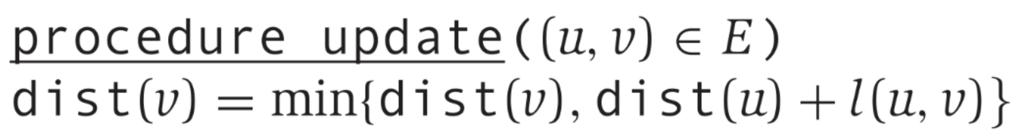

**Claim 2:** *Suppose is a shortest path . Then, if we initialize and for all , , and we perform at least one on every edge in that shortest path in order, then afterwards,* .

*Proof.* By induction on . Exploit Claim (2) from Lecture Notes 5(a).

### Bellman-Ford Algorithm

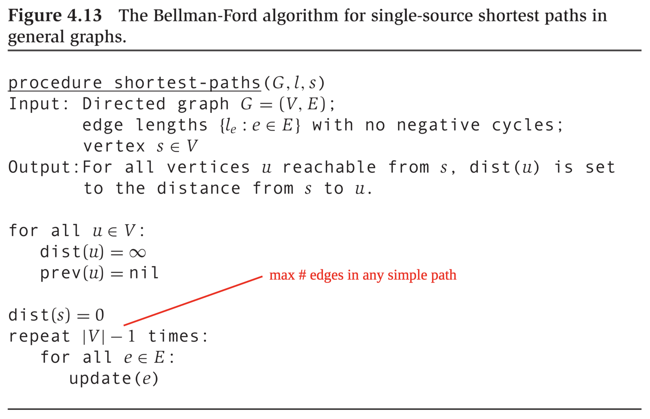

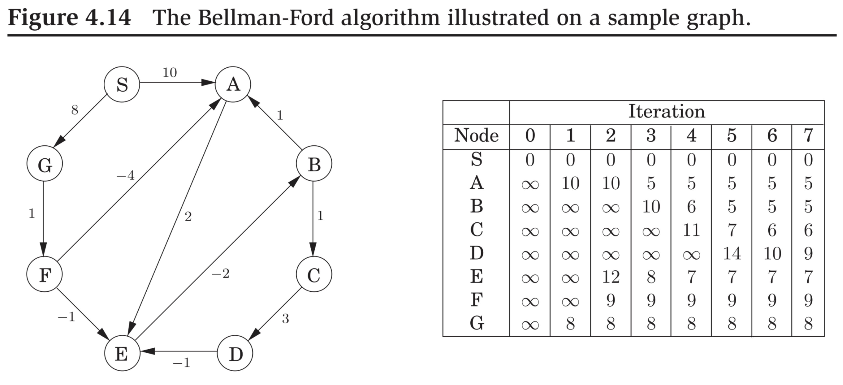

Time efficiency of Bellman-Ford: .

* : Best case elicited by and .
* : Worst case elicited by .

### Directed Acyclic Graphs (DAGs)

Shortest paths (distances) in DAGs:

After we linearize, all paths run left to right. Exploit Claim (2) above.

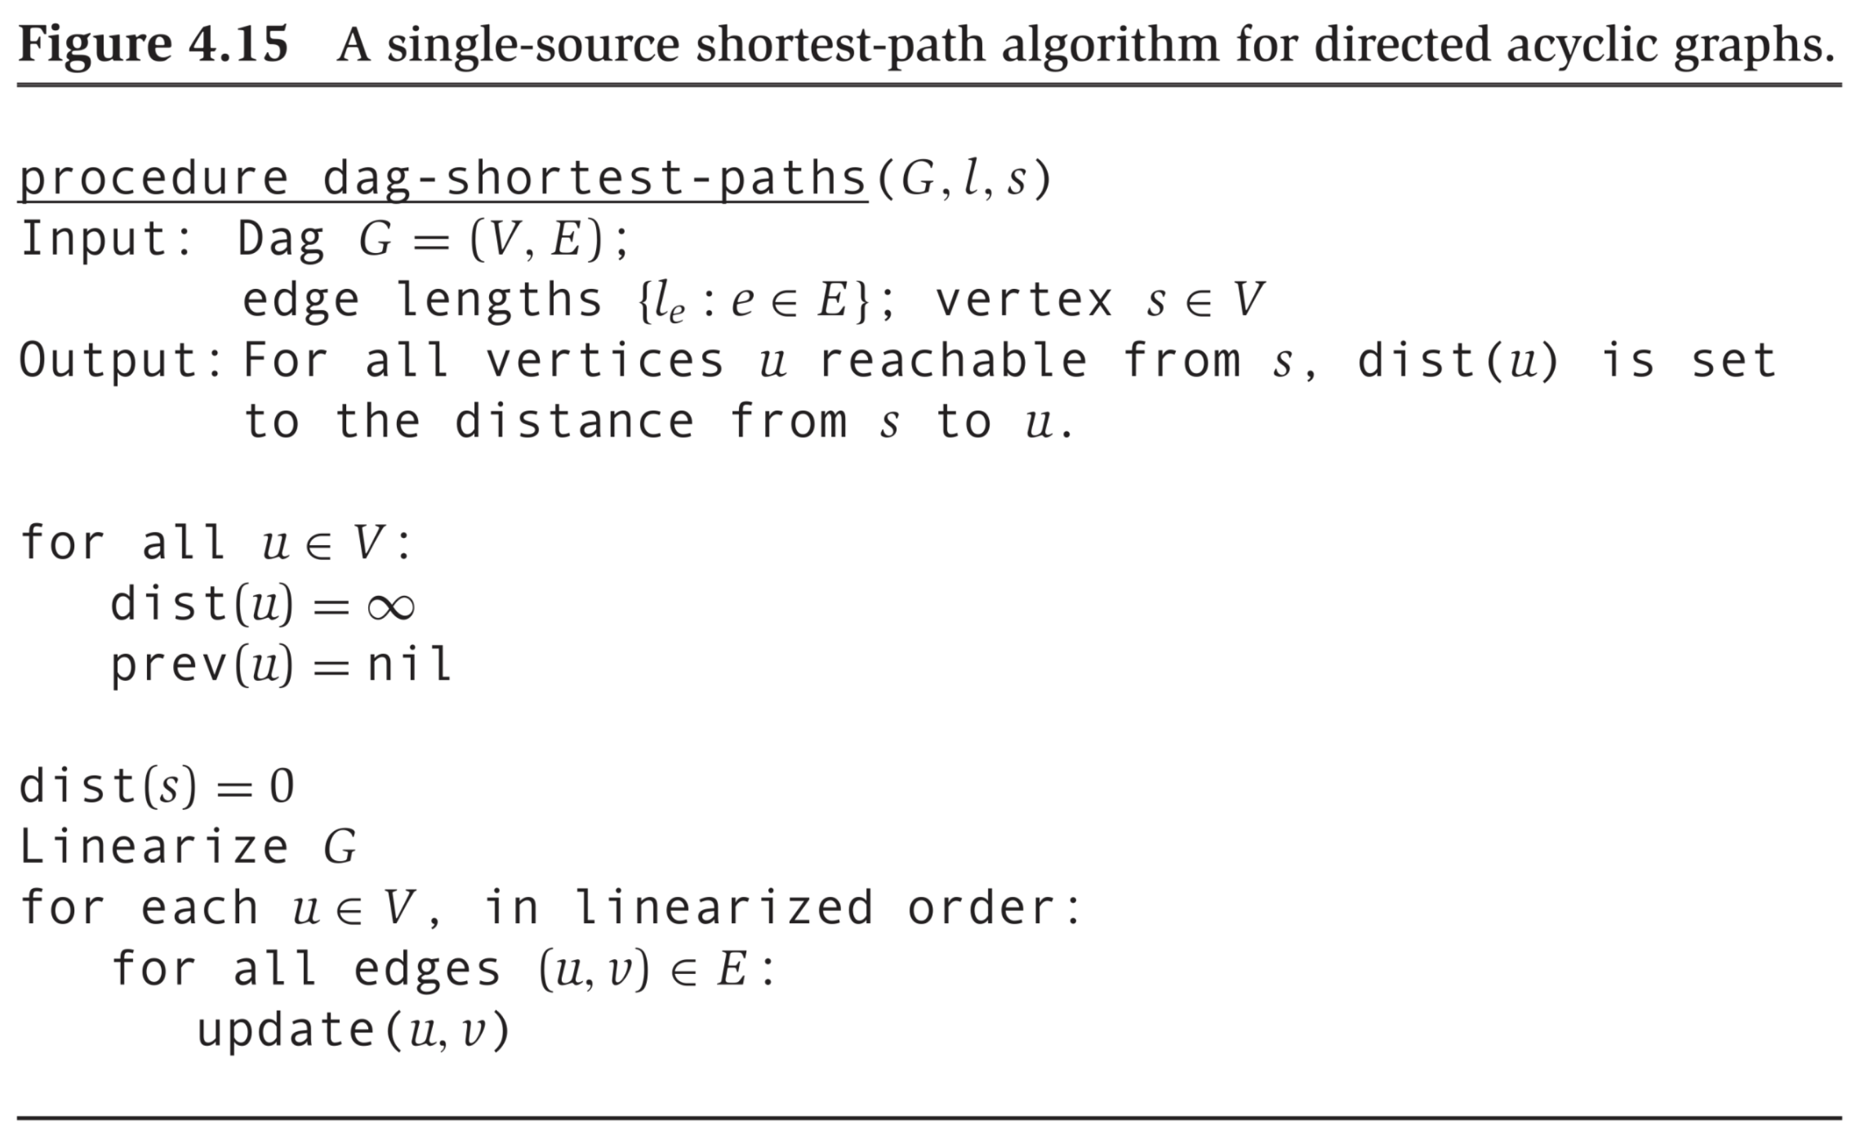

# Greedy Algorithms

## Greedy Algorithms

**Greedy Algorithms:** Exist only if the problem possesses the greedy choice property.

Optimization Problem: Longest/shortest/cheapest/largest/smallest/etc.

* E.g., shortest paths in a graph.

Greedy Choice Property: Property that some (and only some) optimization problems possess.

*There exists a sequence of locally optimal choices that leads to a global optimum*.

* E.g., shortest paths in a graph in which edge weights are non-negative.

### Minimum Spanning Trees

* Tree: An acyclic connected undirected graph.
* Spanning tree of a connected undirected graph : A subgraph of where: (i) , (ii) , and (iii) is a tree.
* Minimum spanning tree of an edge weighted connected undirected graph : A spanning tree of with the property:

Given any spanning tree of ,

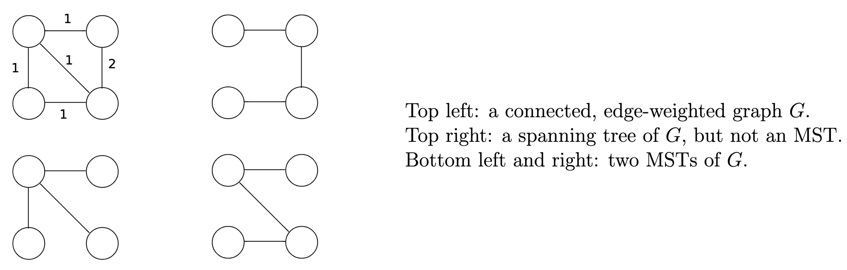

Efficient algorithm for a spanning tree: BFS. Not correct if we seek MST.

An algorithm for MST: Kruskal’s.

*Perceive an MST of as a set of edges,*

*Start with*

*Sort edges in non-decreasing order of weight*

*For each edge in sorted order, add it to provided this does not result in a cycle*

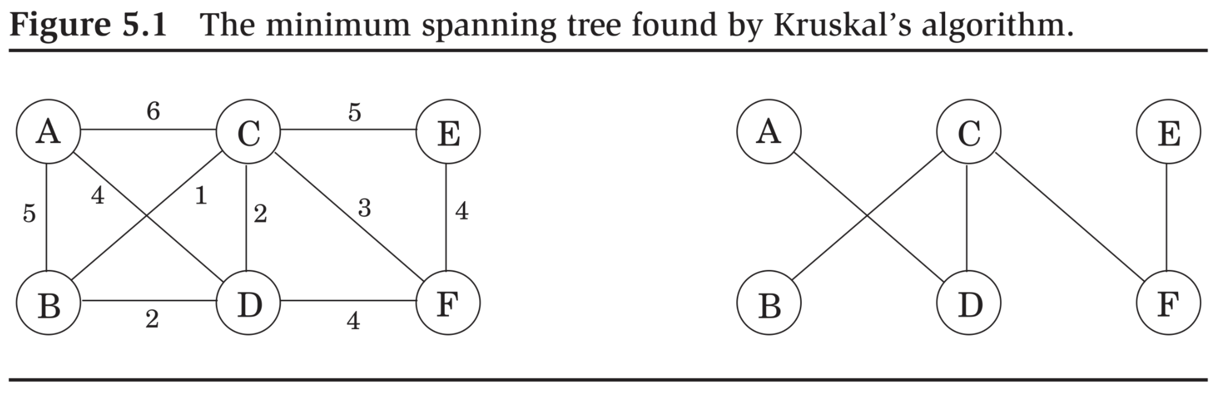

### Correctness of Kruskal

Kruskal is an instantiation of a more general approach. First some definitions.

**Definition 1.** *We define cut, and what it means for an edge to cross a cut.*

* *A cut of a graph is a partition of into two sets, .*
* *An edge is said to cross a cut if one of the vertices is in and the other is in . Otherwise, we say that the cut respects the edge.*
* *We say that a cut respects a set of edges if no edge in crosses the cut.*
* *An edge is said to be a light edge that crosses a cut if amongst all edges that cross the cut, the edge has the smallest weight.*

Now the general approach:

*Suppose edges are part of some MST of . Pick a cut that respects . Let be light edge that crosses the cut. Then is part of some MST .*

Why is the above approach correct?

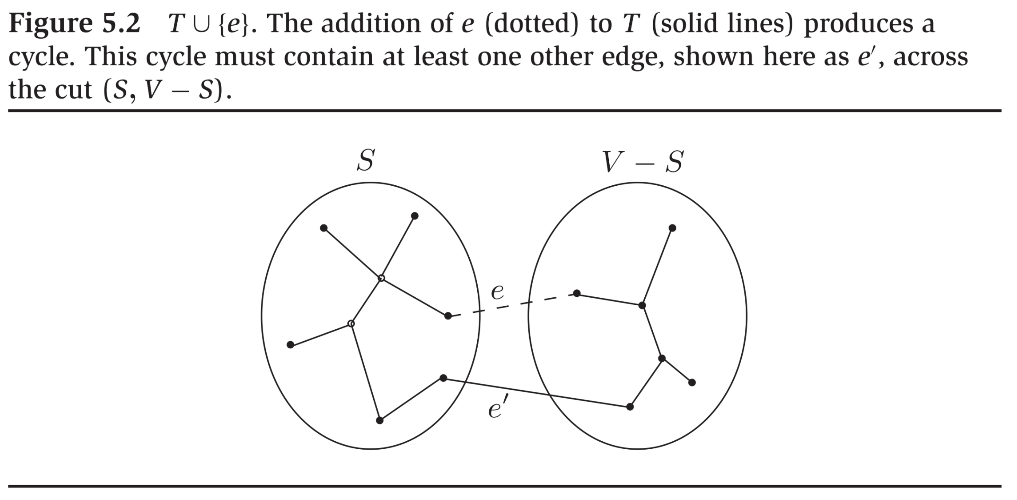

* – is a light edge that crosses the cut.
  + So, the only issue: is a tree?
* has exactly edges.
* It is acyclic because:
  + Removing splits into two connected components.
  + Then adding reconnects these components.

In what wat is Kruskal an instantiation of a general approach?

* Kruskal starts out with each vertex in its own connected component.
* In any step, Kruskal connects two distinct connected components, .
* Kruskal picks a light edge that crosses the cut .

### Time Efficiency of Kruskal

Need to write it down in more detail.

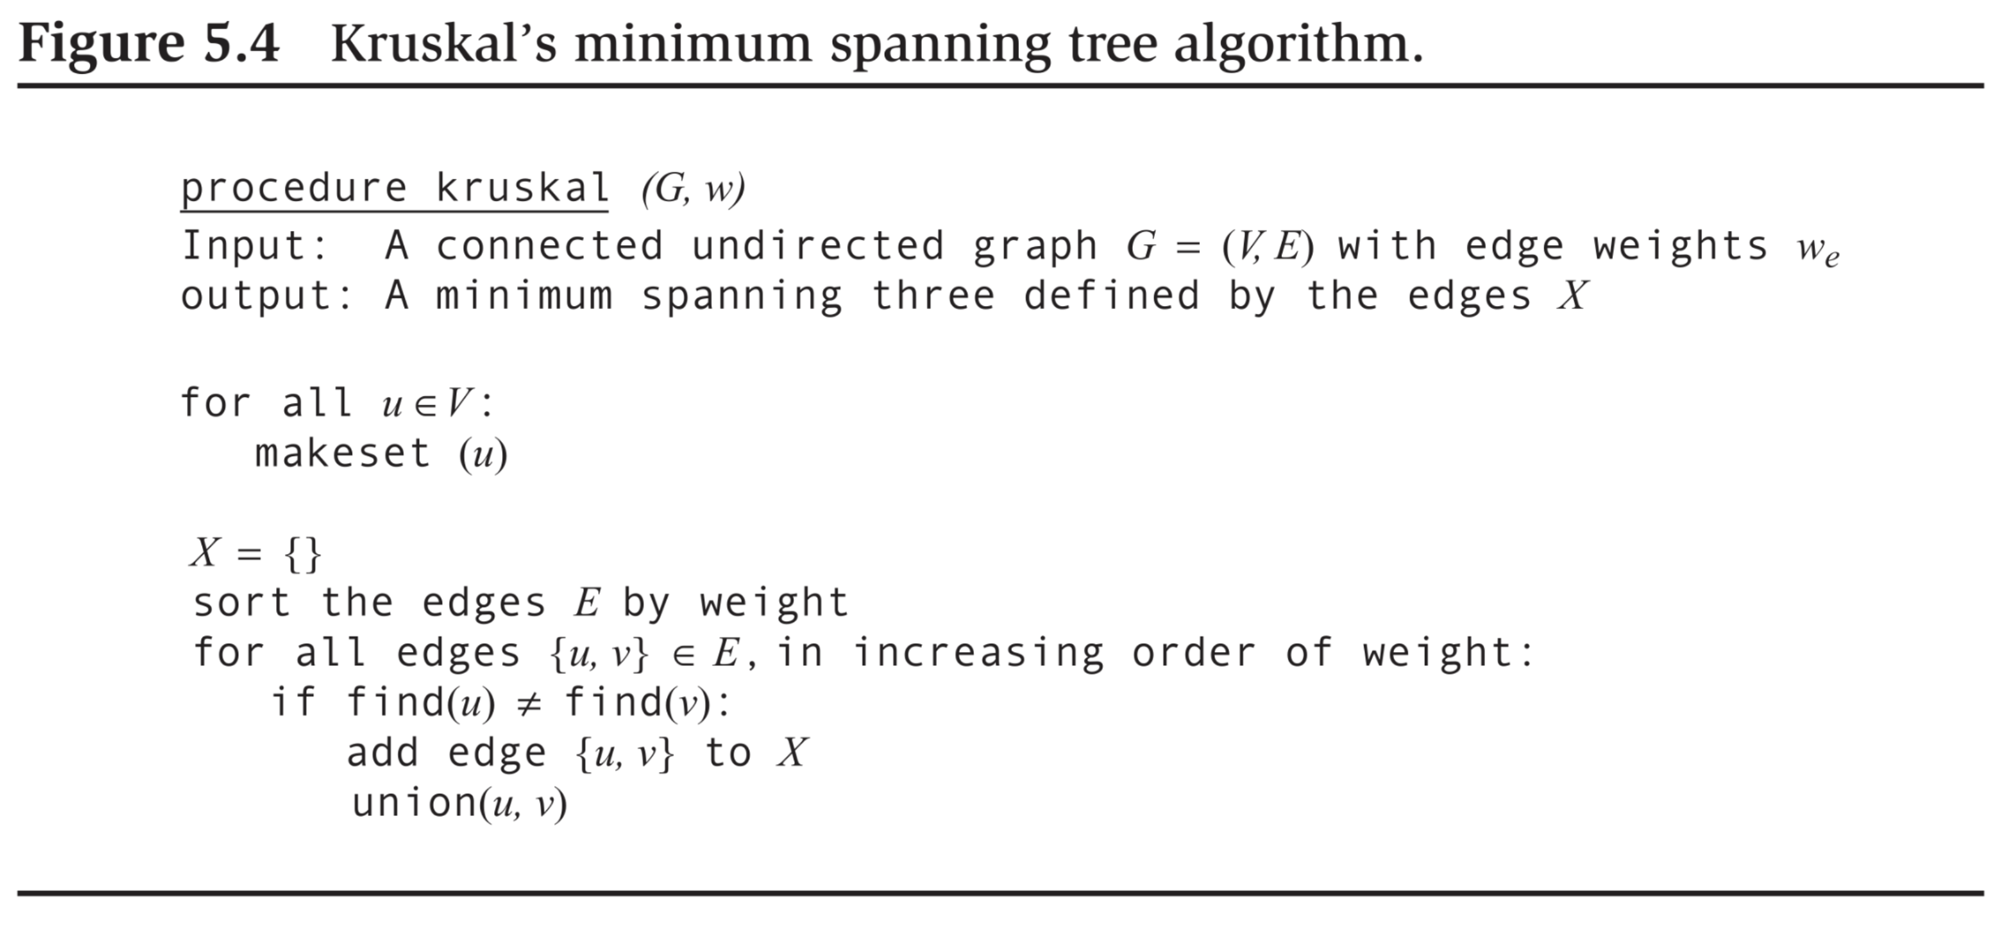

Relies on a *union-find* data structure. API:

* Creates a singleton set that contains .
* Return a unique identifier for the set that contains . So, if and only if and are members of the same set.
* Merge (i.e., union) the sets that contain and . So, henceforth, .

A realization of a union-find data structure: union by rank.

* Maintain a tree of nodes for each disjoint set.
* Each node maintains two attributes:
  + *Its rank* – distance from it to a farthest leaf.
  + *Its parent* in the tree, . For the root, , , i.e., self-loop.

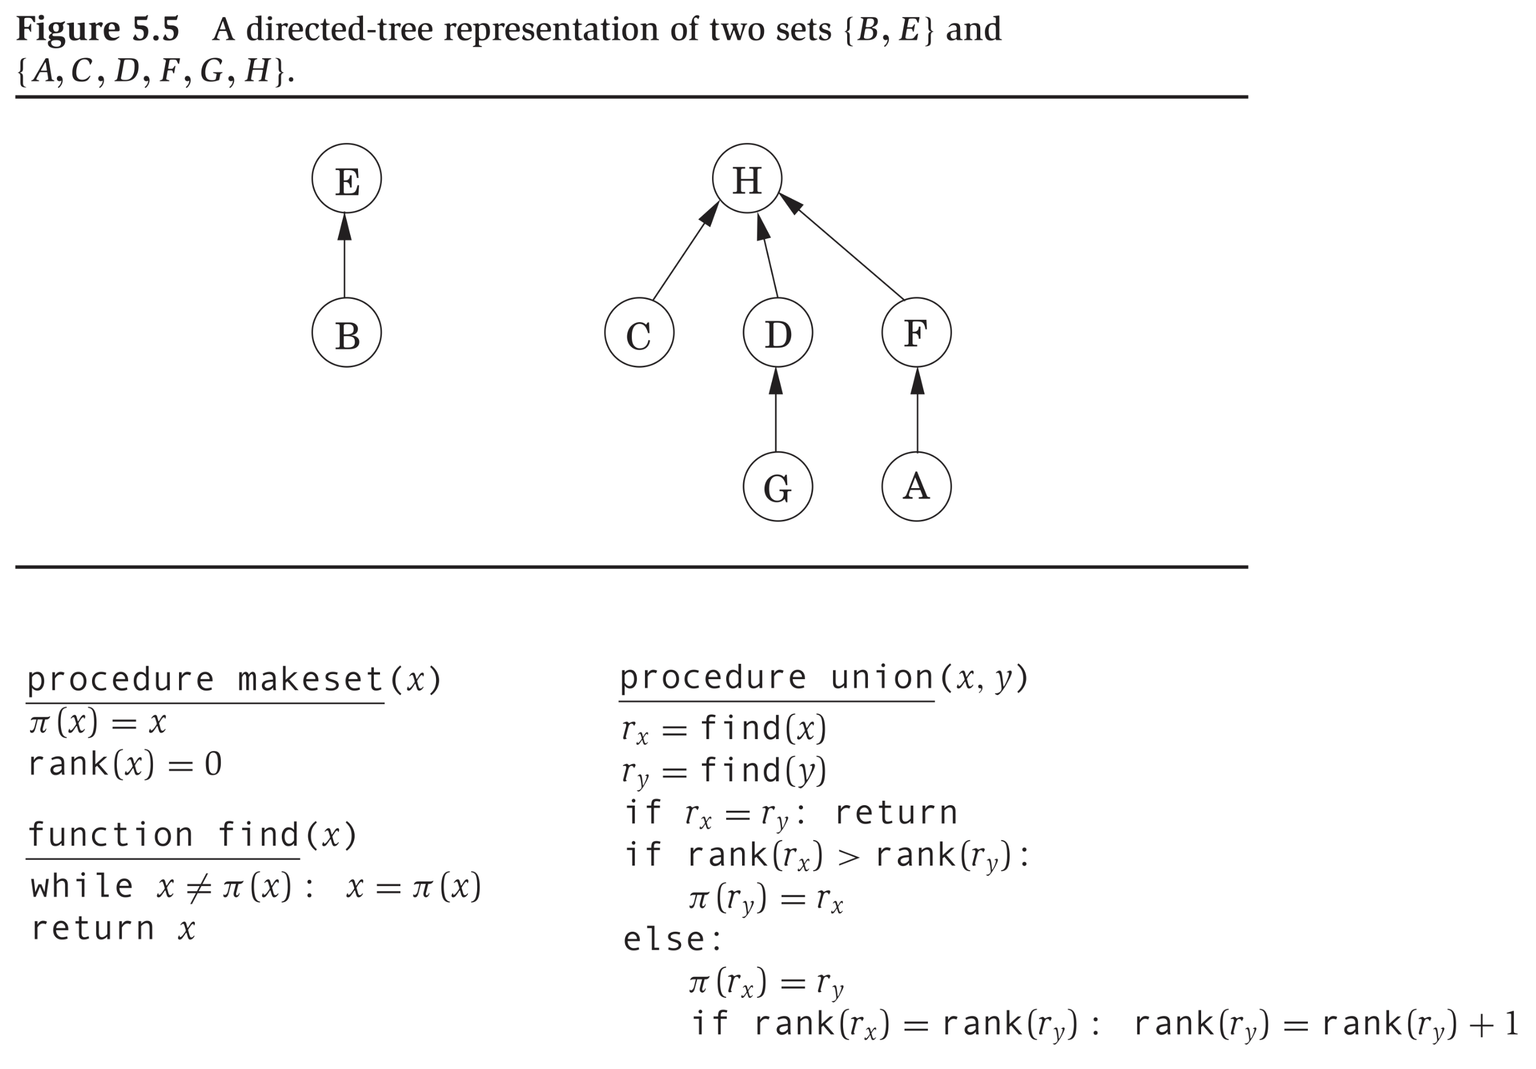

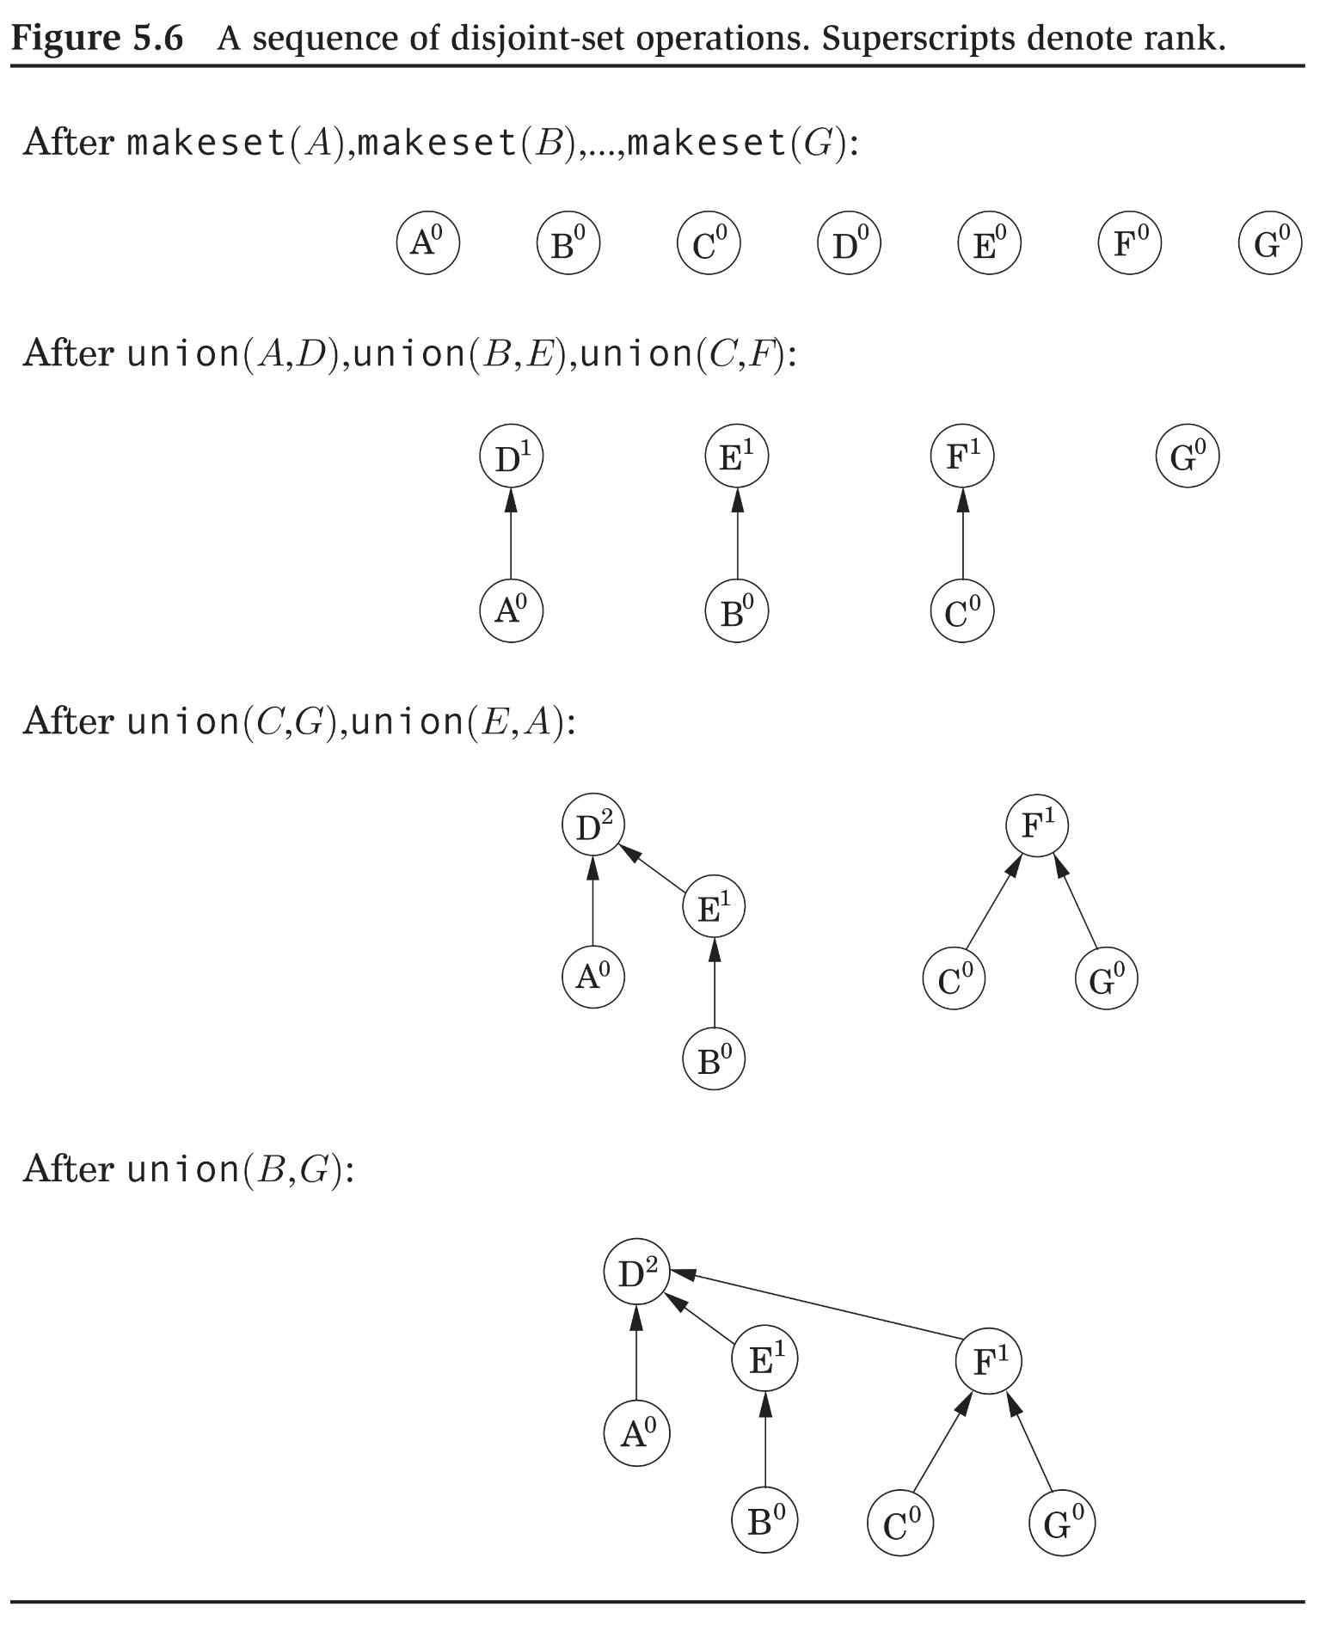

Time efficiency?

**Claim 1.** *In a union by rank tree every subtree rooted at a node of rank has nodes*.

*Proof*. By induction on . True if .

If , the tree rooted at the node is the result of a . Node has at least one child.

If , consider the last operation of trees whose roots had rank . Must have been of two trees each of whose roots had rank . Those two trees each had nodes by the induction assumption. So, tree after has nodes.

**Claim 2.** *The height (longest path from root to a leaf) in a union by rank tree is* .

So, time efficiencies of union-find as realized by union by rank:

* .
* .

So, time efficiency of Kruskal:

* First observe because , .
* So, .
* .
* .
* .

.

## Path Compression

**Path Compression:** To improve the time efficiency of in the union by rank data structure.

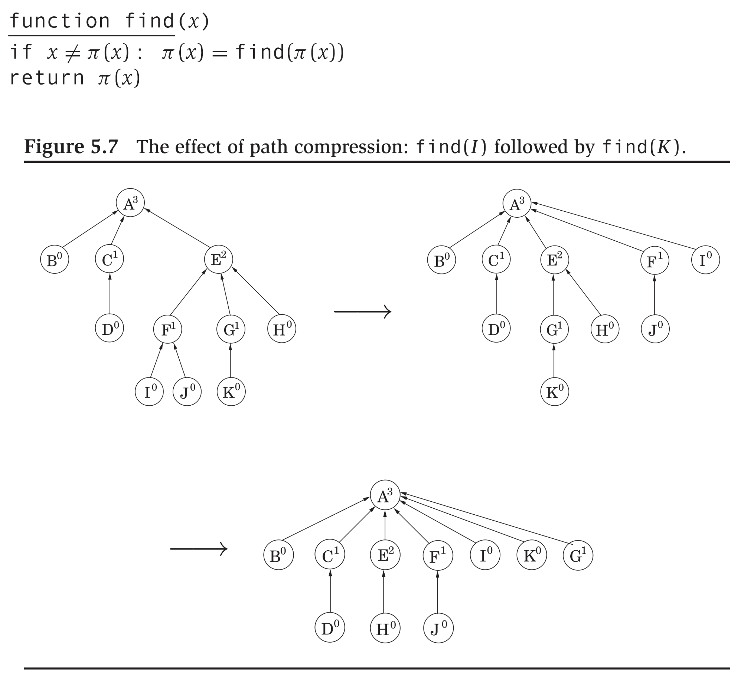

### Analyzing the Benefit from Path Compression

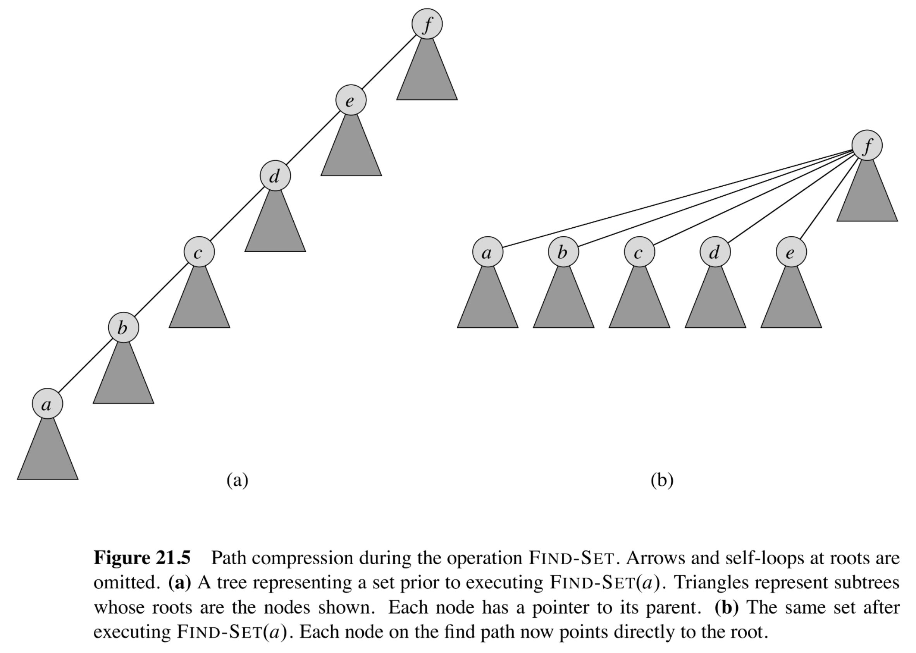

This analysis is simpler than the textbook but suffices to illustrate the benefit.

**Claim 1.** *Suppose we make a total of calls to , and , where calls include the ones made in , then the total time is* .

*Proof.* First, we assume that the following all have some constant cost, :

* An invocation ,
* Everything excluding the time for the two ’s in a call to ,
* An invocation of to an that is an immediate child of a root,
* An invocation of to an that is a root, and,
* The time to execute everything in an invocation to , but not the time for any recursive ’s that result. So, taking one “step up” the tree has a cost of .

Thus, the only variable is if we have an invocation to where is of distance from the root. This would end up costing us .

Now, in terms of our accounting, we do the following. For each invocation , rather than associating it with a cost of only, we associate with a cost of . This is amortization – we are paying an up-front additional cost in anticipation of later cost for .

Why ? The reason is that we are paying an up-front cost of the additional for the first (and only the first) invocation to for each that may happen in the future.

Now consider the cost of . We have two cases.

1. is either a root or the immediate child of a root – then, our cost is . Note that may be an immediate child of a root because we have invoked before already on , perhaps as a consequence of invoking on a descendent of .
2. is neither a root nor an immediate child. Then, we end up with recursive invocations of until we hit an ancestor of that is the immediate child of a root. Then, it must be the case that on and all those ancestors, this is the first invocation of . For which we have already paid up-front cost. So, the only cost for this is also , which is for the ancestor that is an immediate child of the root.

Thus, our total cost is:

* for each ,
* for the work in each except for the calls to , and,
* for each call to .

In total over calls, this cost is .

## Prim’s Algorithm, and Min-Cut

### Prim’s Algorithm

Prim’s Algorithm: Another one that uses the cut property but works differently from Kruskal’s. But it is also a greedy algorithm.

In fact, Prim is exactly Dijkstra’s, with a tweak.

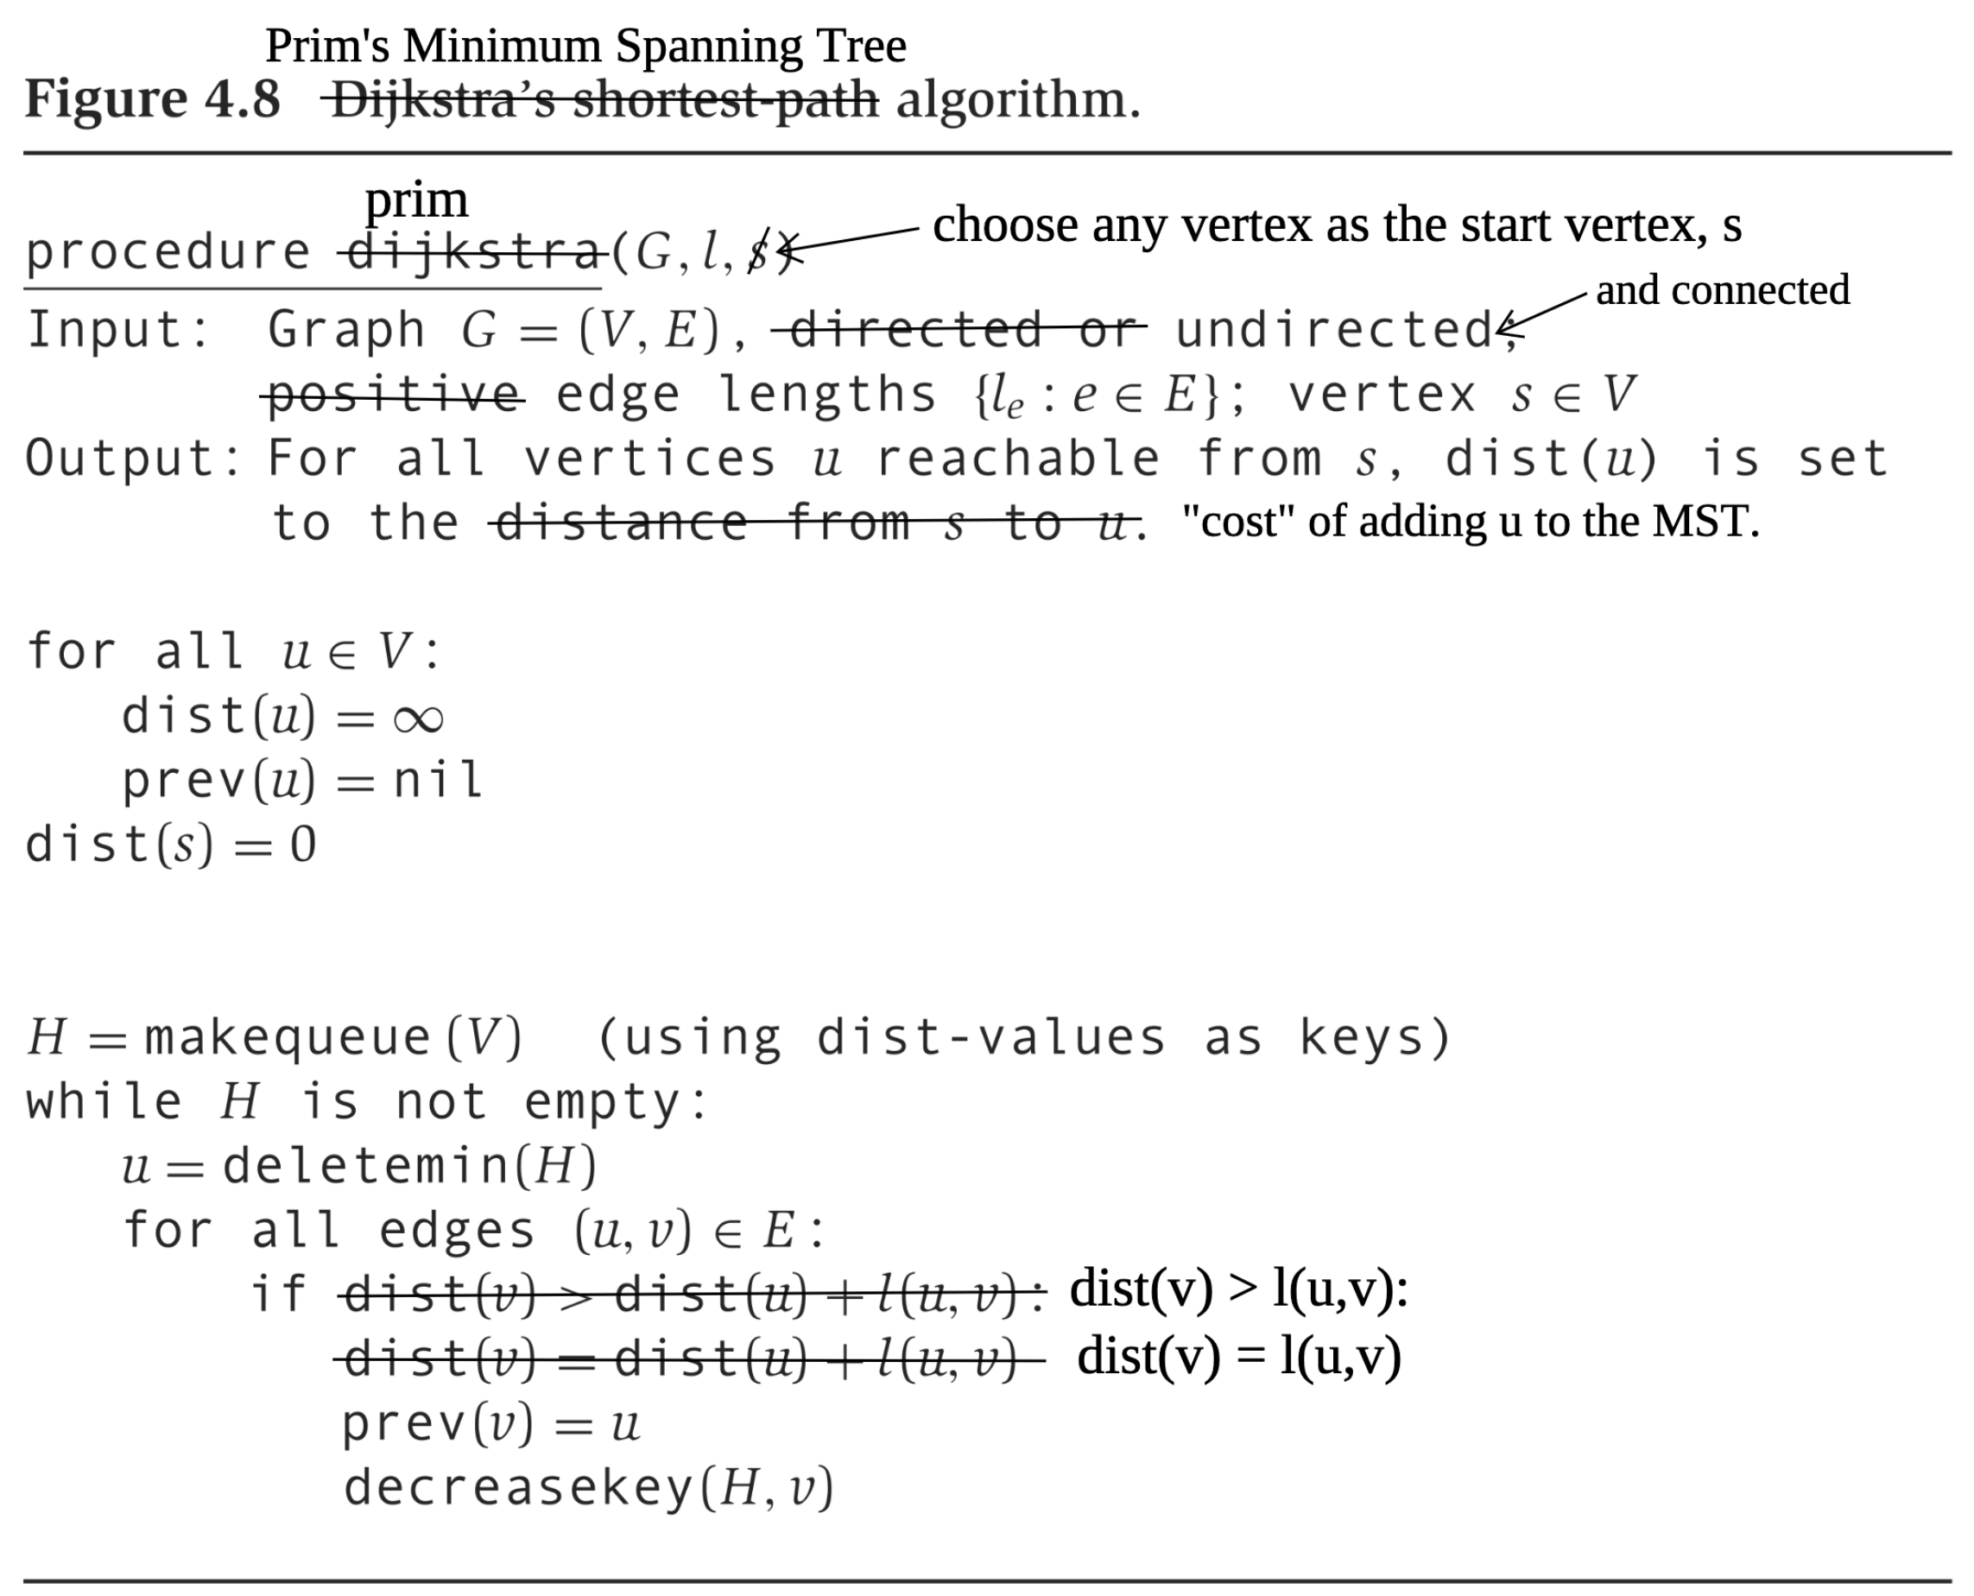

Example:

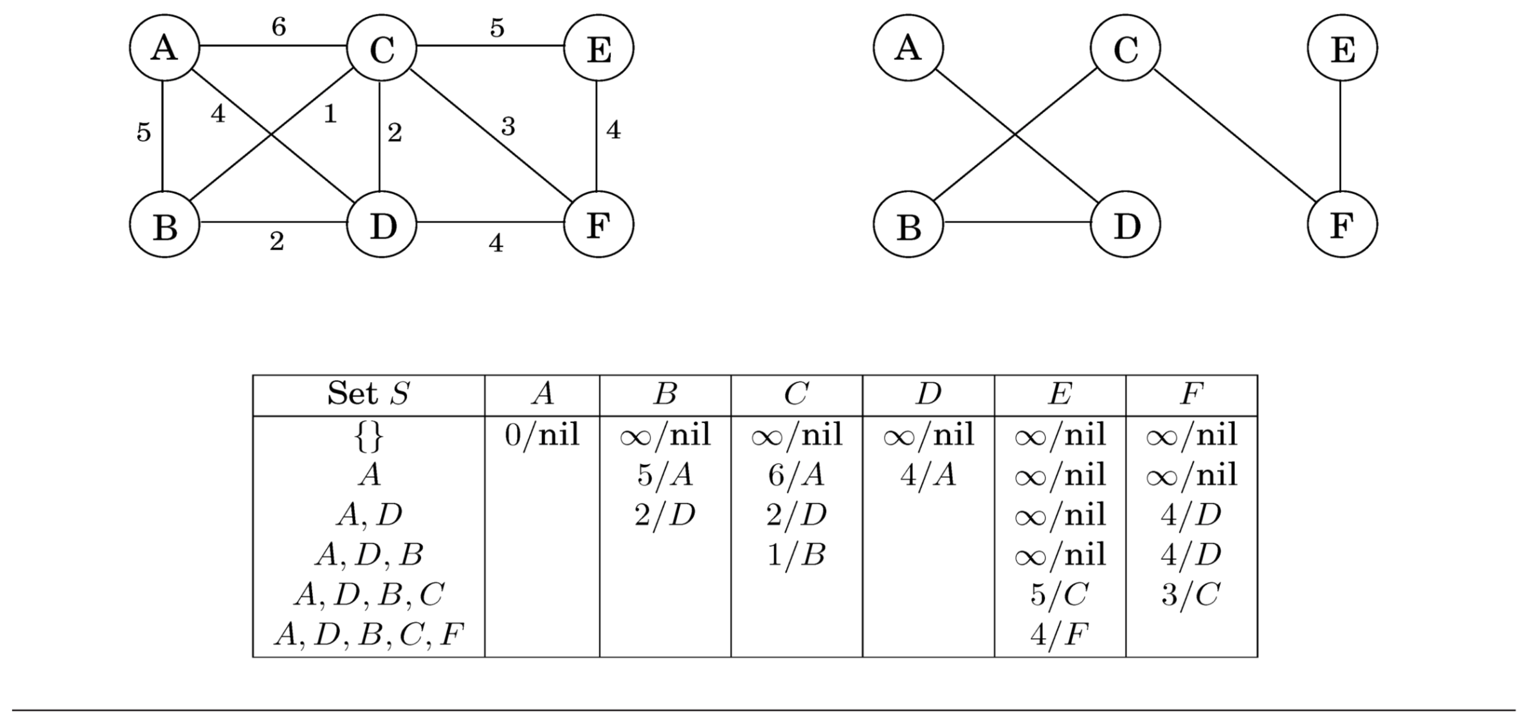

Proof of correctness for Prim: At any moment, we have a set which are connected to the start vertex by a path and whose edges are in some MST. Consider the cut . In the next step, we pick as edge a light edge that crosses that cut.

### Min-Cut

Problem statement:

Input: Undirected, connected (unweighted) .

Output: A cut where , such that the number of edges that cross the cut is minimized.

E.g., suppose we have input the following graph.

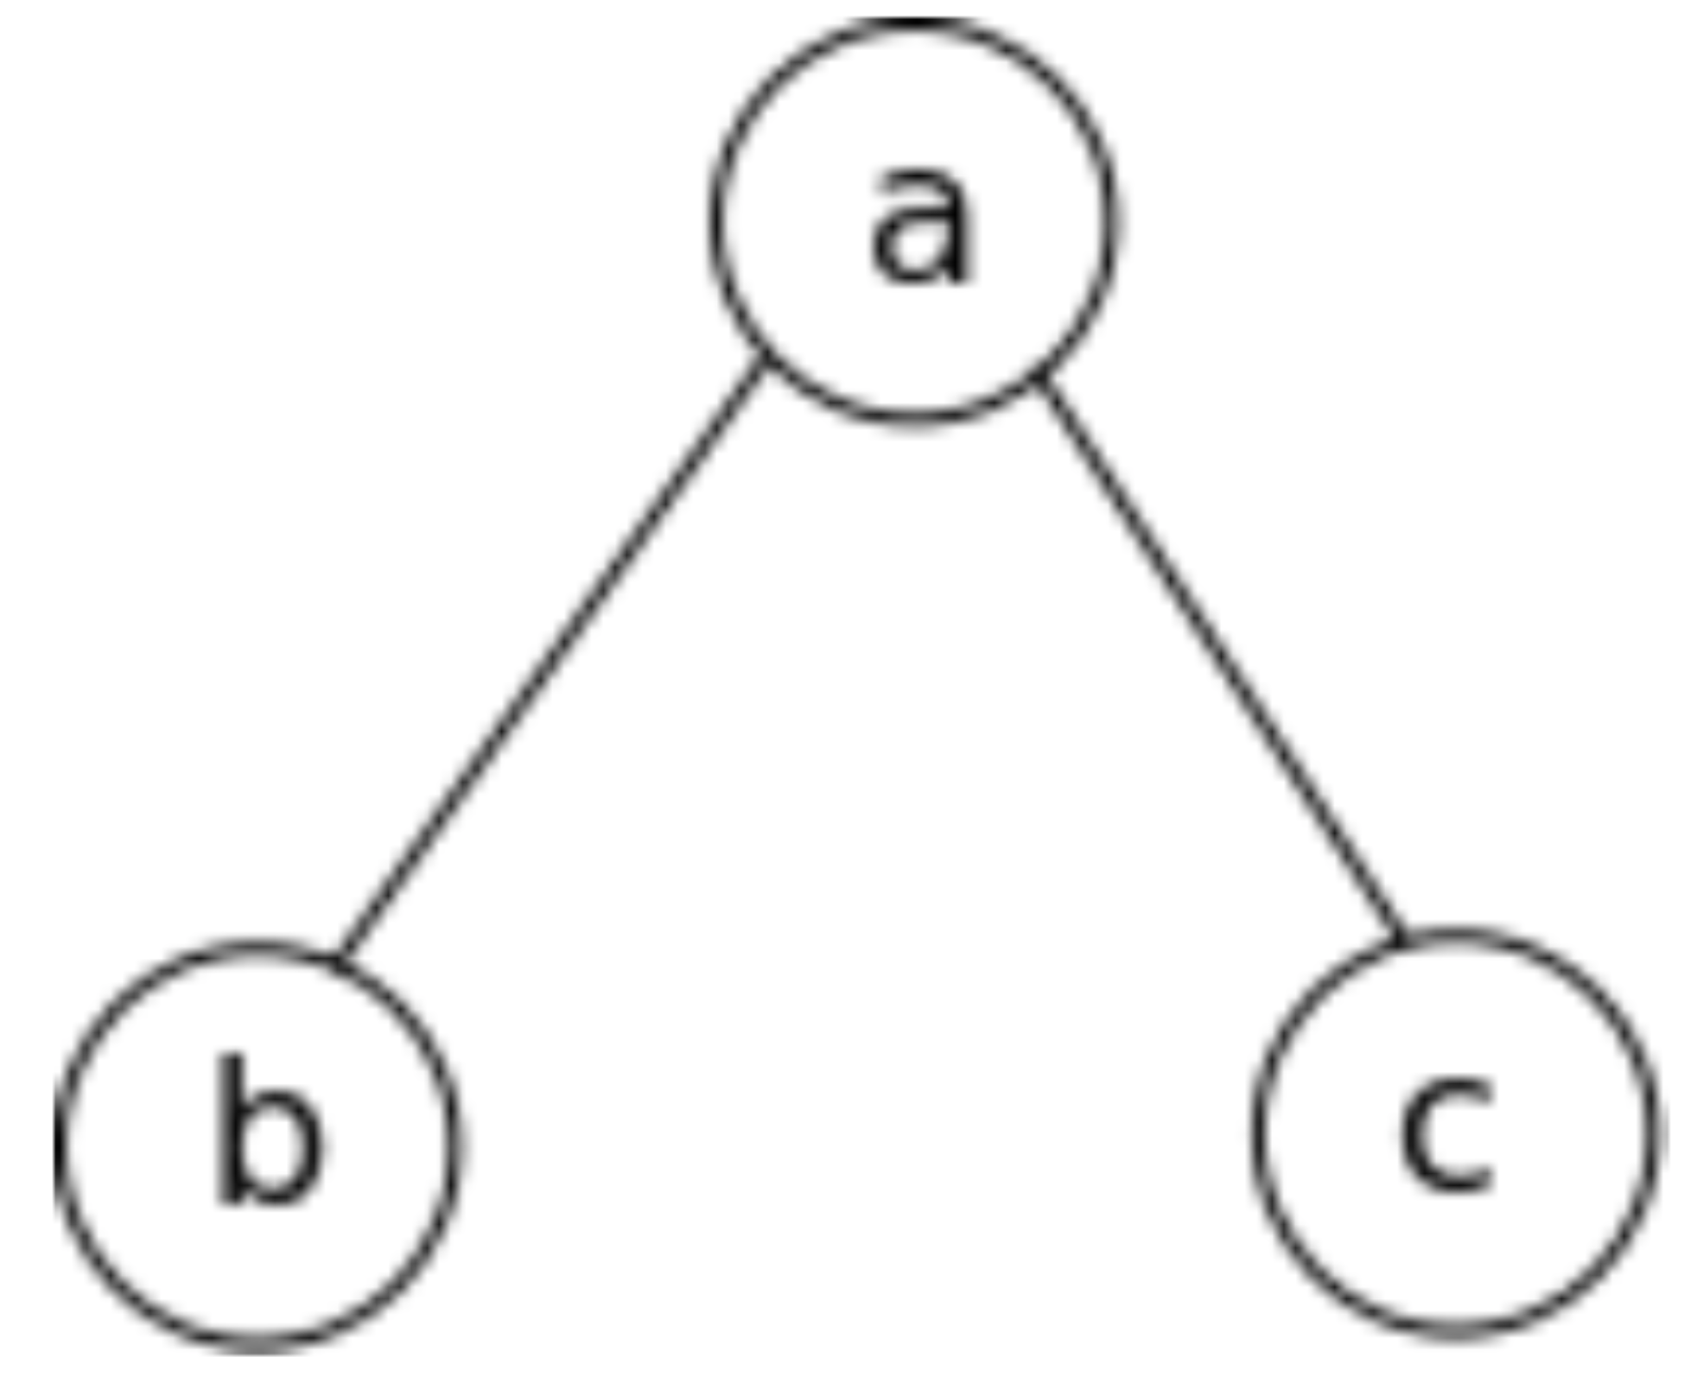

Then is not a min-cut, but is.

A candidate, randomized algorithm: repurpose Kruskal.

*Assign same weight, e.g., , to all edges.*

*Shuffle edges so they will be chosen uniformly at random by Kruskal.*

*Run Kruskal.*

*Remove the last edge picked by Kruskal.*

At the end, we end up with a cut such that each of is a connected component.

**Claim 1.** .

*Proof.* Let be the size of a min-cut of . At any stage of Kruskal just before the last edge is added, is partitioned into connected components. The number of edges that connects any connected component to any other number of edges incident on any connected component .

If we have such connected components, then Kruskal has edges from which to pick an edge to add next.

So, .

So, .

As this event in each round of edge-picking is independent of the other:

## Huffman Coding and Horn Formulas

More examples of problems that possess the greedy choice: Huffman coding and Horn formulas.

### Huffman Coding

Huffman coding problem statement:

Input: A string in some alphabet,

Output: A binary encoding of that string that is *unambiguous* and of minimum length

E.g., suppose you want to encode the string *aabaaccadddd* in binary.

An option: . In this example, 2.

Then, .

Better option: Allocate based on frequency.

|  |  |
| --- | --- |
| **Symbol** | **Frequency** |
|  |  |
|  |  |
|  |  |
|  |  |

E.g., .

Ambiguous. Decoder does not know whether decodes to *adb* or *bb*.

Huffman coding:

* Bit-string codes and codes neither nor is a prefix of the other.
  + E.g., ; then code for is a prefix of code for – not allowed.
* Maintain property that higher frequency shorter code.

E.g., .

So, length of code for .

Another example:

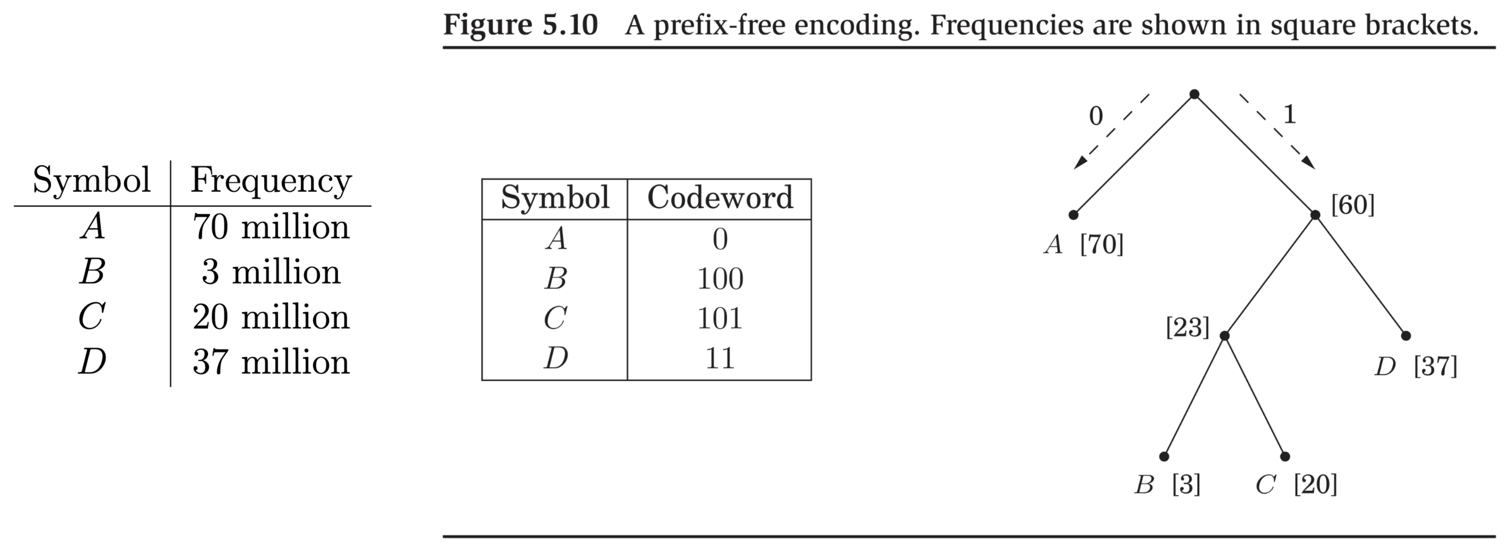

Turns out:

* Prefix-free codes such as the above can achieve optimal compression.
* Problem of building such an optimal tree possesses a greedy choice property:

Starting with each symbol in a singleton set of itself, pick the least frequently occurring set to build the tree bottom-up.

* That is, designate leaves corresponding to each symbol . Assume they are ordered in non-decreasing frequencies .
* Make siblings by creating an internal node, call it . Remove and from future consideration but add a new “symbol” with frequency for future steps. Then repeat.
* E.g., the above example would run as follows:
  + .
  + .
  + .
  + .

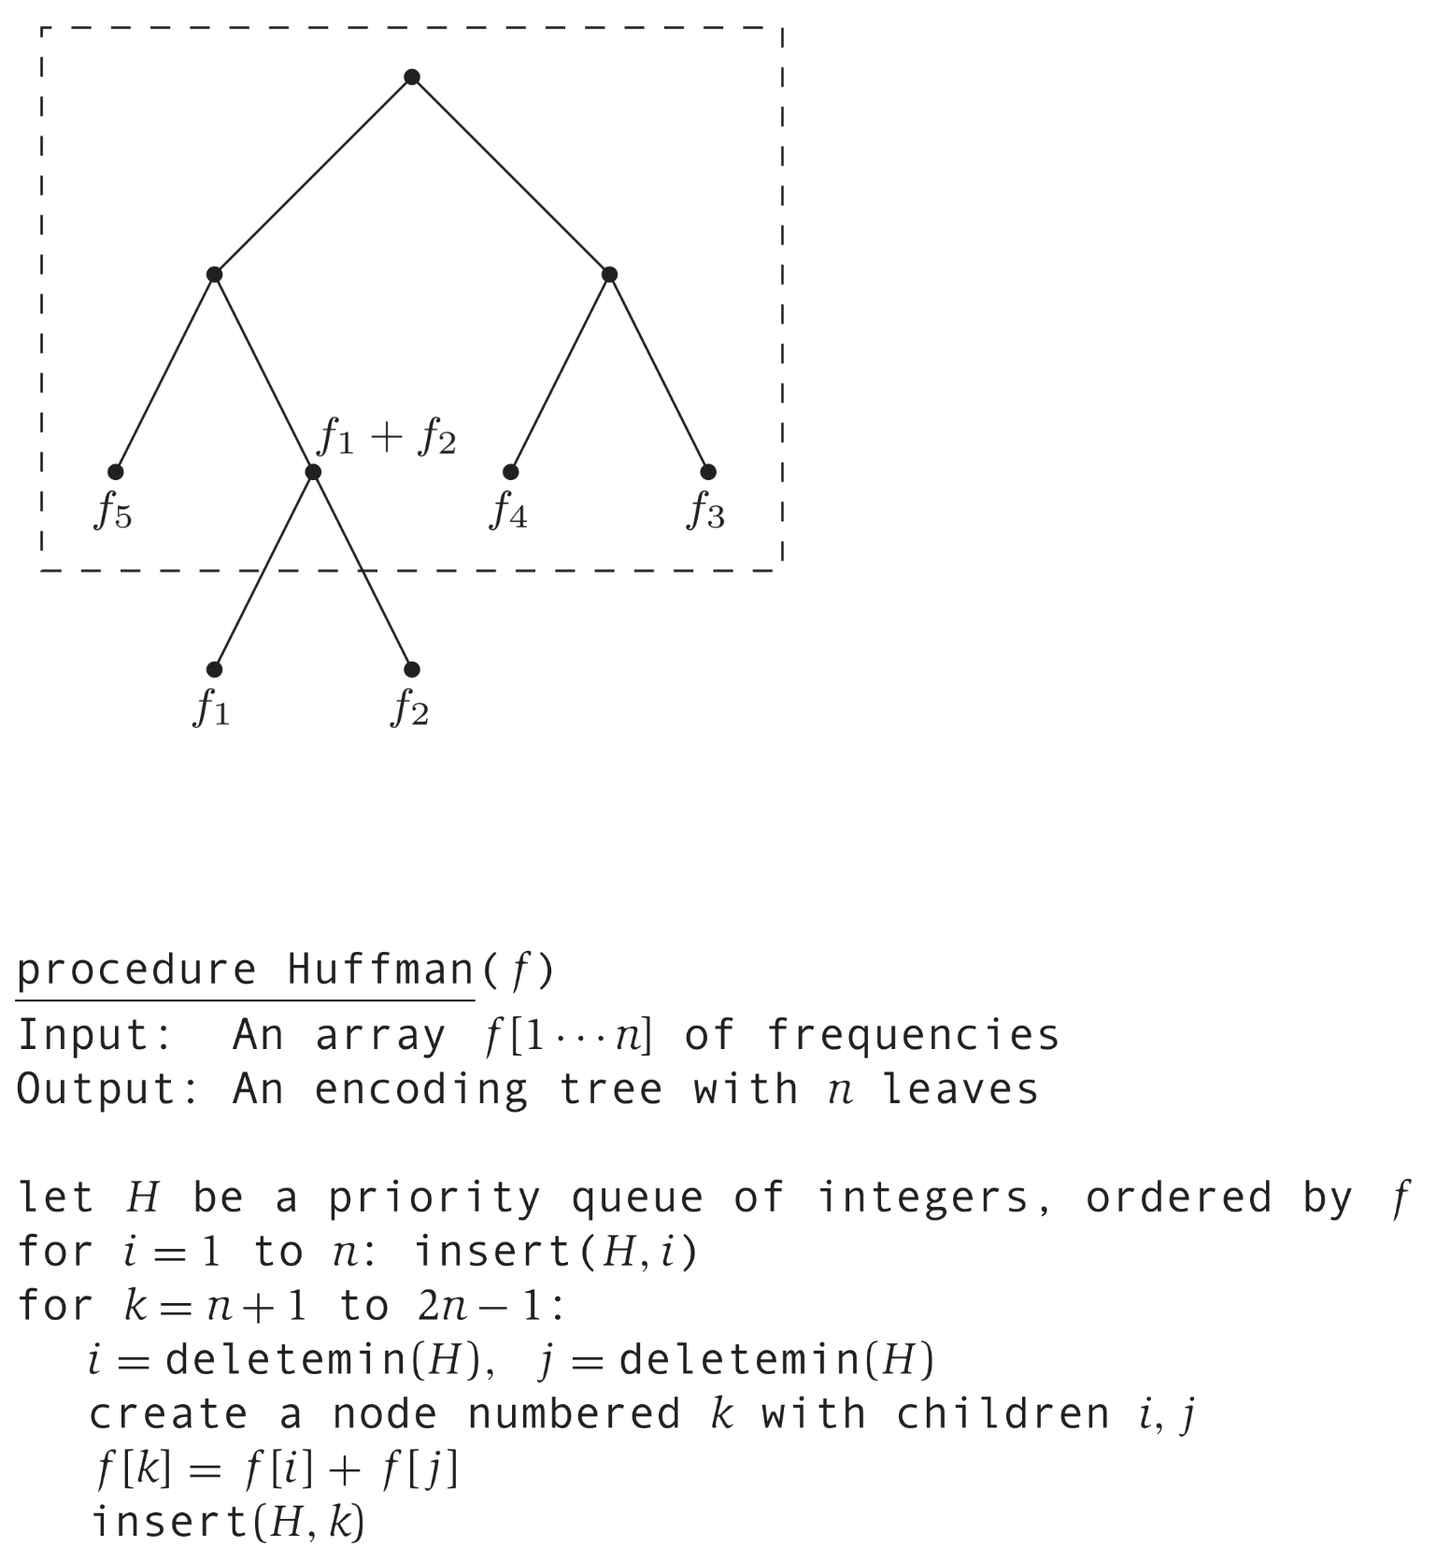

Proof of correctness: Has one assuming prefix-free codes can achieve optimality. Proof is similar to the way we proved cut property for Minimum Spanning Tree.

### Horn Formulas

Satisfiability of Horn formulas:

* Special case of particular interest of Boolean satisfiability problem.
* A *boolean variable*, , takes a value of either **true** or **false**.
* We allow *propositions* or *clauses* or *formulas* to be built from boolean variables using boolean operators: .
* A proposition/clause/formula also has a truth value. A *semantics* tells us the truth value (i.e., **true** or **false**) of a clause given truth values of constituent variables.
* One more piece of commonly used terminology: a *literal* is either a boolean variable or its negation.

We adopt truth table based semantics.

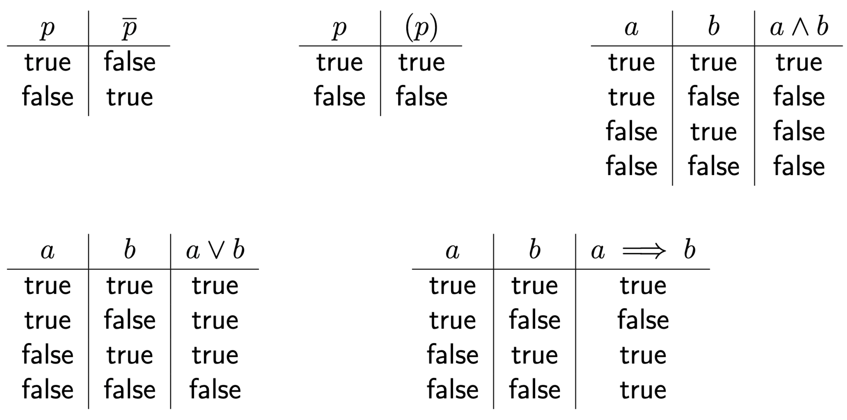

Boolean satisfiability problem:

Given a boolean formula as defined above, does there exist an assignment of truth values to its constituent variables that causes the formula to evaluate to **true**?

Examples:

* The formula is satisfiable.

is a satisfying assignment.

* is not satisfiable.

In Horn satisfiability, we restrict the formula to a particular type.

* Formula is a conjunction of clauses, i.e., .
* Each clause constrained to be one of the following two types.

1. Implication of a particular form: Left hand side is conjunction of zero or more positive literals; right hand side is a single positive literal.

Examples:

* + - (read as “if **true** then )

1. Pure negative clause: Disjunction of one or more negative literals.

Examples:

Example of a formula:

A greedy (or “stingy”) approach to determining Horn satisfiability:

*Set every variable to* ***false****.*

*Set variables to* ***true*** *one-by-one only if we must*.

In our example, in order:

* must be set to **true** – clause: .
* So, must be set to **true** – clause: .
* So, must be set to **true** – clause: .
* So, formula is not satisfiable – clause: .

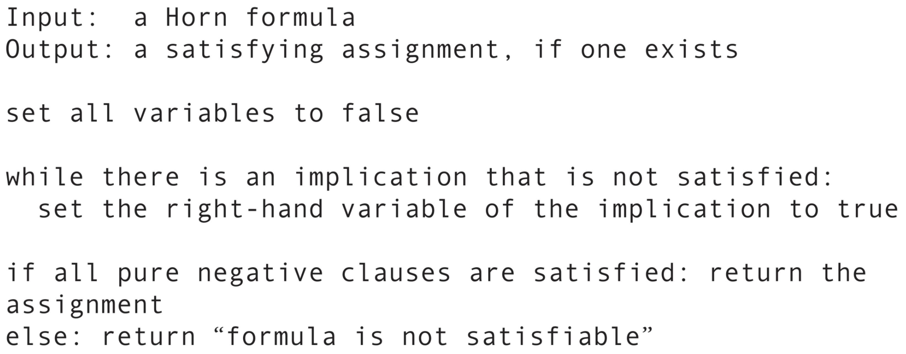

**Claim 1.** *The above algorithm sets a variable to* ***true*** *if and only if in every satisfying assignment, that variable is* ***true***.

Time efficiency of algorithm: .

* Where is the length of input formula.